[Egyptian Informatics Journal 23 (2022) 271–290](https://doi.org/10.1016/j.eij.2022.01.004)

Contents lists available at [ScienceDirect](http://www.sciencedirect.com/science/journal/11108665)

Egyptian Informatics Journal

journal homepage: [www.sciencedirect.com](http://www.sciencedirect.com/)

[](http://crossmark.crossref.org/dialog/?doi=10.1016/j.eij.2022.01.004&domain=pdf)A novel optimization algorithm (Lion-AYAD) to find optimal DNA protein synthesis

Samaher Al-Janabi b,⇑, Ayad Alkaim a

a *Department of Chemistry, Faculty of Science for Women (SCIW), University of Babylon, Babylon, Iraq*

b *Department of Computer Science, Faculty of Science for Women (SCIW), University of Babylon, Babylon, Iraq*

a r t i c l e i n f o

*Article history:*

Received 25 May 2018

Revised 8 February 2020

Accepted 22 January 2022

Available online 12 February 2022

*Keywords:*

Intelligent bioinformatic analysis Optimization

Synthesis Lion-AYAD DNA

PSO COA WOA LOA

Spirally searching and Bubble net searching mechanism

a b s t r a c t

In this paper, we present a new algorithm to find the optimal proteins generated through DNA synthesis. The algorithm executes in five stages: in the first stage, it takes a DNA sequences and consider it as the initial populations of lions, determined the main positions of each lion and the main distances among lions and goal point then consider this distance as fitness of that lions, after that sort the lions based on their fitness to preparing it to the second stage. The second stage develops lion optimization algorithm (LOA) by adding four new features on it, each feature performance one task, a replacing the kernel of LOA (i.e., searching machnizam) by spirally searching & Bubble net searching to increase the accuracy, at the same time reduce the execution time to reach of the goal achieve by A Smart feature. The main purpose of the third stage is determining lion active or more yauld where each lion in population need update the positions and fitness after each move in searching space to reach of their goal., this achieved through Yauld feature. The fourth stage applies the Cooperative features to convert the active sequence of DNA (i.e., Yauld lion) into mRNA after that built tRNA from it after splitting it into triplet to start to generate the proteins. Synthesis of all triplet of tRNA to generated final proteins result by new optimization algo- rithm achieved based on deep composite that satisfies the four rules, this feature called Deep feature and represent the final stage of the algorithm. The new algorithm appears as a pragmatic optimization model, it proves their robust to work with dynamic length of DNA sequence. It increases accuracy and reduces execution times.

© 2022 THE AUTHORS. Published by Elsevier B.V. on behalf of Faculty of Computers and Information,

Cairo University. This is an open access article under the CC BY-NC-ND license ([http://creativecommons.](http://creativecommons.org/licenses/by-nc-nd/4.0/)

[org/licenses/by-nc-nd/4.0/](http://creativecommons.org/licenses/by-nc-nd/4.0/)).

1. Introduction

DNA replication is semi-conservative in nature. DNA is com- prised of a double-stranded helical base of nucleotides. This double strand ‘‘unzips” at the beginning of the replication process, sepa- rating into two single strands, which can be copied. Each of the two strands is then replicated, resulting in two new daughter strands of DNA from the parent helix, while conserving the original

* Corresponding author at: Department of Computer Science, Faculty of Science for Women (SCIW), University of Babylon, Babylon, Iraq.

*E-mail addresses:* [samaher@itnet.uobabylon.edu.iq](mailto:samaher@itnet.uobabylon.edu.iq) (S. Al-Janabi), [alkaim@iftc.](mailto:alkaim@iftc.uni-hannover.de) [uni-hannover.de](mailto:alkaim@iftc.uni-hannover.de) (A. Alkaim).

Peer review under responsibility of Faculty of Computers and Information, Cairo University.

**Production and hosting by Elsevier**

base sequence of the parent strand. *(a) Continuous DNA Replica- tion,* and (*b) Discontinuous DNA Replication*.

Optimisation is an overall term used in many areas, intelligent computation in different types also in different sciences to reach of the best values (i.e., These values take multi names such as min- imum, maximum, less cost, high performance, etc.) Based on the nature of the problem and what the researchers need to prove from this problem (i.e., Based on the objective function/functions of the problem). Sometimes the field of used determined the specific def- inition of term optimization.

In this paper, we will focus on optimization of the side algo- rithms by enhancing the search machnizam and add new capabil- ities into one of the optimization algorithms that begin search on optimal values based on specific strategy apply on initial popula- tion and in each step attempts to find the best path and values allowed it to near from their first sub goal, Then Second etc. to reach of the final goal (i.e., search sequence of sub goals to reach of the final solution of problem). The main properties should con-

<https://doi.org/10.1016/j.eij.2022.01.004>

1110-8665/© 2022 THE AUTHORS. Published by Elsevier B.V. on behalf of Faculty of Computers and Information, Cairo University. This is an open access article under the CC BY-NC-ND license (<http://creativecommons.org/licenses/by-nc-nd/4.0/>).

tain in any optimization algorithm are robustness; efficiency and accuracy.

Synthesis have multi definitions based on the purpose of it such as: ‘‘(a) the composition or combination of parts or elements so as to form a whole. (b) the production of a substance by the union of chemical elements, groups, or simpler compounds or by the degra- dation of a complex compound. (c) The combining of often diverse conceptions into a coherent whole also: the complex so formed”. While another definition ‘‘(a) deductive reasoning. (b) The dialectic combination of thesis and antithesis into a higher stage of truth” As a result, we can define synthesis as the procedure opposite analysis procedure, where Synthesis refer to combine separate elements or components in order to form a coherent whole

Lion Optimization Algorithm is one of the optimization algo- rithm derivatives from the natural community behaviours and cooperative among lions such as prey capturing, mating, territorial marking, defense and the other behaviors. We can summarization it’s performance by find the best solution. Therefore, this paper will focus on develop that algorithm by add new prosperities on it to find the optimal proteins from DNA Sequences. Table 1 shown compare among the main optimization techniques

1. Related works

Optimization is the act of getting the finest result beneath given circumstances. The optimization divided into (maximization mini- mization, single variable multi variables, with without constrains). There are two types of objective functions optimization, single objective function and multiple objective function. Optimization has three basic elements which are decision variables, objective, and constraints. An optimization algorithm is distinguished a pro- cedure which is executed iteratively by comparing various solu- tions till an optimum or a satisfactory solution is found, there are many types of optimization namely continuous optimization, bound constrained optimization, constrained optimization, derivative-free o optimization, discrete optimization, global opti- mization, linear programming and nondifferentiable optimization. Multi researchers work in the field optimization.

Alkaim and Al_Janabi [14] propose a new prediction method focused on the development of MARS data mining by replacing the kernel with a multiobjectives optimization feature. To find a parallel gas flaring rate based on three main gases (CO2, CH4, N2O) that improves the efficiency and decreases the time spent finding the optimum result. In this analysis, too, measure the oil rate (GOR) of gas. Zawbaa et al. [1] suggested a binary ALO for the collection of the functions. The findings show that binary ALO will outperform traditional PSO and GA in a substantial way. Zawbaa et al. [2] have enhanced ALO ’s usefulness in the treatment of function selection tasks by introducing a new ALO (CALO) based on confusion. In Lab VIEW TM Gupta et al. [3] built a new toolkit based on ALO. Yamany et al. [4] employed ALO to refine MLP ’s link vectors. They used only four datasets and the findings show that ALO will outperform ACO, PSO, and GA.

Rajan and Malakar [5] suggested ALO (MALO) for the treatment of Optimum Reactive Control Dispatch (ORPD) tasks in power sys- tems and the results confirm the MALO’s robustness and accuracy. Al_Janabi el. al. [13] build model called Multi Objectives Renewable Energy Generation (MORE-G) based on constructions and multi objective optimization methods. Through design two models of optimization; first called Develop Cuckoo Optimization Model (DCOM) based on enhance the performance of Cuckoo search opti- mization by apply the horizontal combination on it, While the sec- ond Develop the CapsNet Model (DCapsNet) based on using multi layers network and each layer apply different activation function then combination results through linear combination to satisfy the optimization concept.

Kamboj et al. [6] have used ALO to solve a nonconvex ORPD problem in an efficient way. Ali et al. [7] used basic ALO to handle effective distributed generation allocation and sizing (DG). The comparative findings showed ALO ’s superiority over other meta- heuristics, such as Artificial Bee Colony (ABC), Firefly Algorithm (FA), Cuckoo Quest (CS), Ant Colony Optimization (ACO), GA and PSO. Even the basic ALO was used to handle the combined planning and scheduling tasks [8]. Raju et al. [9] developed an ALObased method for controller optimisation at the same time. Dubey et al.

[10] applied simple ALO to arranging hydrothermal-wind (HTPGS) functions.

Table 1

Compare among the Optimization Techniques.

Techniques of Optimization

Discrete

Optimization

Advantages Disadvantages

* Give efficient solutions. ● Generate a series of persistent sub-problems.
  + A complicated way.
  + Give illogical results.

Unconstraint Optimization

Constraint Optimization

None, One or Multi objectives

Deterministic Optimization

Stochastic Optimization

* Helps solve the most common

problems.

* Works on applications with clear restrictions.
* You find a solution that fully sat- isfies your problem.
* Number of steps to find the goal limited and known
* Most time led to near from local optimization
* The cost is expected lowest.
* High cost very Limited estima- tion to appear.
* Need to the previous information to discovery it.
* In real time the information can adapts.
* Can work with the total or group or part of information
* The classification is based on the information available on the function to be optimized.
* The method is more complicated than Unconstrained Optimization.
* Some goals are replaced by restrictions.
* All the variables related and not related to the goal take into account when design the optimization model, therefore, this led to more computations and complexity
* Very difficult compute the probabilities.
* Require compute the probability of all scenarios.
* Not suitable all the time

The findings demonstrate ALO ’s strengths and benefits in obtaining better-quality technologies while meeting a lot of real- world hydro, thermal, and wind generation constraints. Mirjalili et al. [11] suggested the multiobjective version of ALO (MOALO), and the findings show the high utility of this approach in real- world engineering solutions

Al-Janabi and Alkaim [12] present a novel tool called DRFLLS to fine the optimal values to missing values. By developing random forest algorithm, seven categories of similarity measures were defined. These categories are person similarity coefficient, simple similarity, and fuzzy similarity (M1, M2, M3, M4 and M5). Al-Janabi and Madi [15] present study based on intelligent compu- tation through deep analysis to five prediction data mining tech- niques to determine which one achieve an optimal biomedical analysis, this study appear not the mathematical computation always lead to optimal solution as popular but the nature of data is consider the main parameter in determined the optimal way

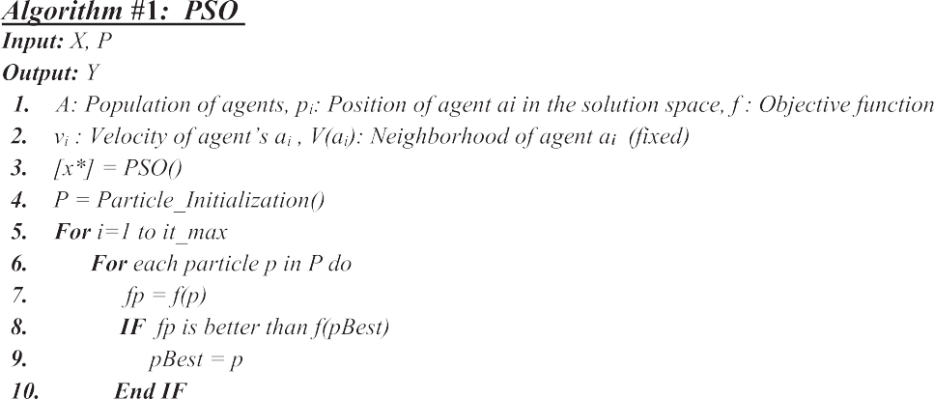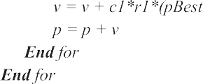



of solve any problem. Mahdi and Al-Janabi [22] present a study for the main challenges in the healthcare field. The goal is to iden- tify patients who will be admitted to the hospital within the next year by using historical claims data including Information about patient and analysis it to solve the problem. Through build the pre- dictor that satisfies the three points: ‘‘Speed execution”, ‘‘abilities to deal with very huge databases” and ‘‘predict the number of days the patients spend in the hospital in the next years.

1. Main optimization algorithms

This section focuses on the discovery and analysis the beha- viours of the main optimization algorithms to compare the beha- viours and performance of new algorithm Lion-Ayad with them later

* 1. *Particle swarm optimization (PSO)*

Particle swarm optimization (PSO) is a computational method that optimizes a problem by iteratively trying to improve a candi- date solution with regard to a given measure of quality; for more detail see [17]. In general, can summarization the main steps of PSO in algorithm 1

here: c1: acceleration factor related to pbest, c2: acceleration factor related to gbest, r1 : random number between 0 and 1, r2: random number between 0 and 1.

* 1. *Cuckoos optimization algorithm (COA)*

Cuckoos are a bird family with a special breeding technique which is more aggressive relative to the species of other birds.

Cuckoo is an algorithm inspired by nature, built on the basis of cuckoo bird reproduction. See [13,18] for more information, also Algorithm 2

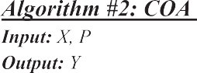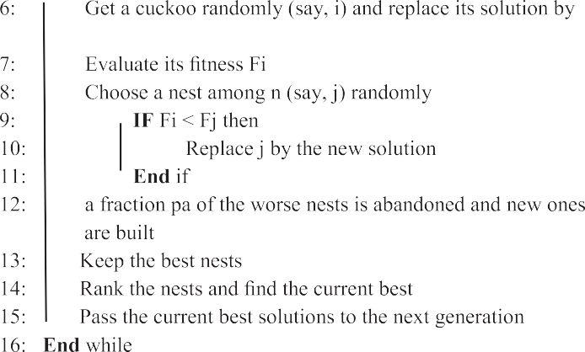

Cuckoo optimization algorithm is very good for problems of glo- bal optimization, as it preserves a balance between local random walk and global random walk. The equilibrium between local

and global random walks is regulated by a parameter pae[0,1] .

The random local and global walks are characterized by the

its principal problem. With the aim of increasing global conver- gence speed and achieving better performance, the WOA optimiza- tion process will introduce chaos. In the proposed chaotic WOA methods, numerous chaotic maps are considered for tuning WOA

’s main parameter which helps to monitor exploration and exploitation. In the recent past, the implementations of the algo- rithm have been widely used in various field because of its opti- mum output and quality [19,20]. The definition of each parameters shown under Table 6.

Eq. (1) and (2), respectively [18].

*Xt*+1 = *Xt* + *aSH*(*pa* — *e*) *Xt* — *Xt* (1)

*i*

*i*

*j*

*k*

D = C * Xkrand

X(t + 1) = X

krand

— X(t) (3)

— A * D (4)

*Xt*+1 = *Xt* + *aL*(*S*; *k*) (2)

X(t + 1) = D * exp (b * l) * cos (2 * pi * l) + X_ (t) (5)

*i* *i*

* 1. *Whale optimization algorithm (WOA)*

The whale optimization algorithm (WOA) is a proposed bio- inspired metaheuristic algorithm which focuses on the collective hunting behavior of the humpback whales. As with other meta- heuristic algorithms, WOA is facing slow convergence speed as

* 1. *Lion optimization algorithm (LOA)*

Lion Optimization Algorithm (LOA) is one of the main optimiza- tion algorithms described in algorithm 4 also LOA have multi parameters [16] and very different from Ant lion optimization (ALO) in strategies of works and parameters [21]; Chaser new

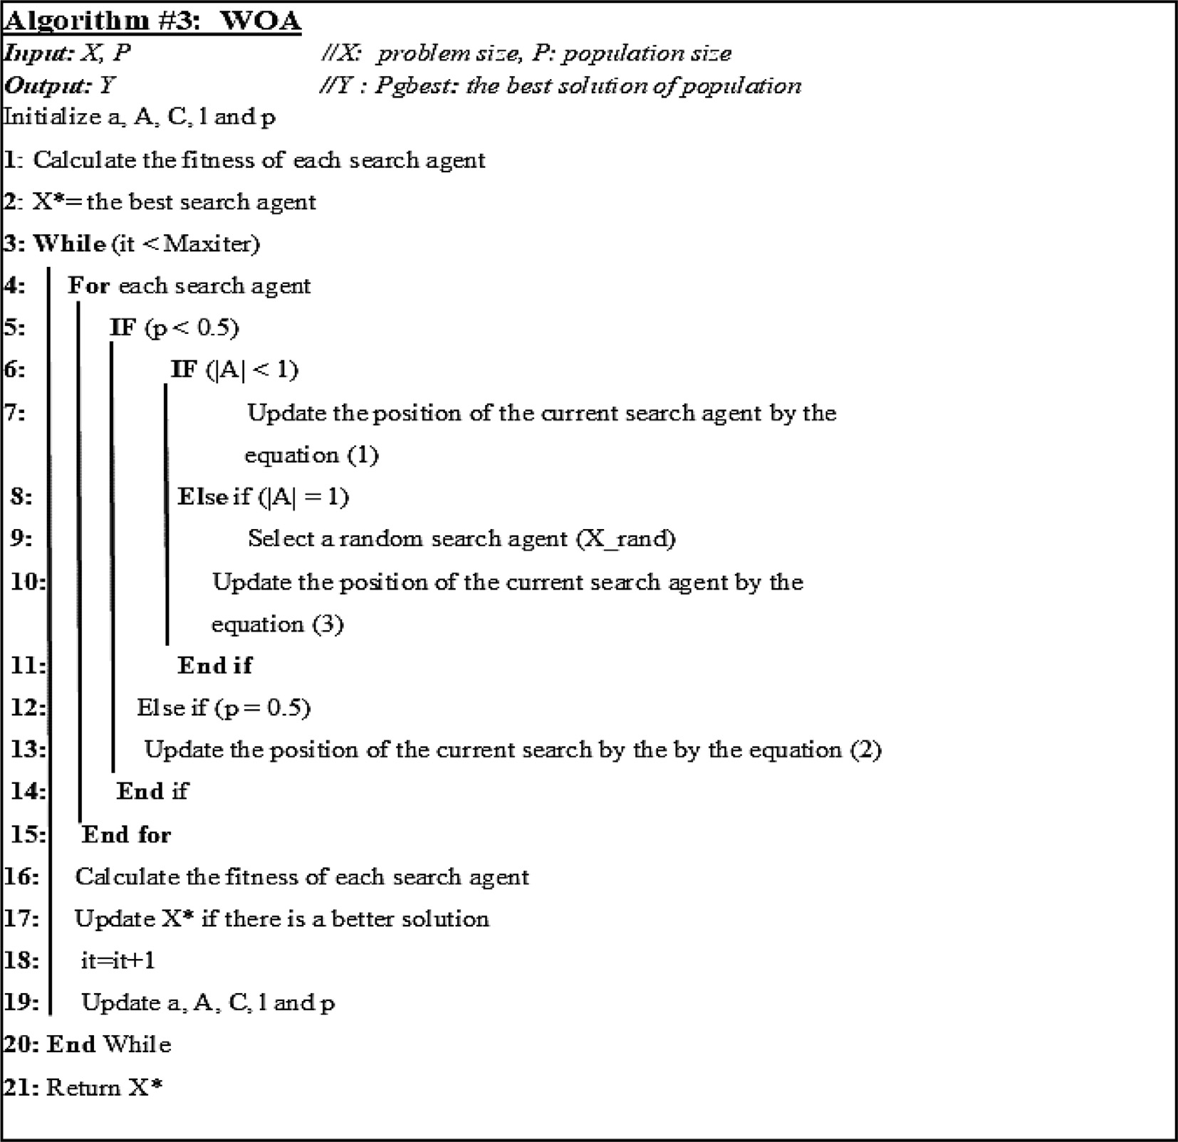

and Chaser are the new and existing positions of each chaser lion, respectively; rand represents a random number between zero and one; and Prey indicates the position of the prey. Winger i; new indicates the new position of Winger hunter lion, and H2 is a ran- dom unit vector perpendicular to vector W, Cheater new repre- sents the new position of the Winger hunter lion, and Cheater is the present position of the Winger hunter lion. Male Lion new indi-

cates the new position of the male lion, and Territory. Best Posi- tions represent the collective understanding of the pride’s members about the search space. The cumulative best positions of the resident lions (including both males and females) are sorted from the best to the worst according to the corresponding fitness; E is an excursion constant; T R indicates the territory ratio. For more details see [16],

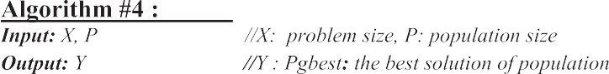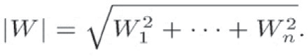

1. Lion- AYAD optimization algorithm (Lion-AYAD)

The main points of the research methodology can represent by the following steps, Algorithm 5 summarized all steps required to generated proteins from the DNA sequences synthesis, we refer to that new optimization algorithm by name Lion-AYAD, the main idea of that algorithm generated from the add new properties to one of the optimization algorithms that prove good performance, Fig. 3 presents the main activities of research work, while Fig. 4 shown the architecture of Lion-AYAD algorithm. Fig. 5 shown the Contribution of each triple concentrations in generation the 20 types of Proteins.

1. Main parameters of new optimizer determined in that step includes number of Population; Max number of Iteration; Current Lion-AYAD. position; initial Lion-AYAD. fitness; area that any lion searching it represent by low boundary and upper boundary.
2. Split the DNA sequences through preprocessing step, for make the algorithm more dynamic, we deal with short and long sequence. At the same times each sequence can have different number of start and end pints.

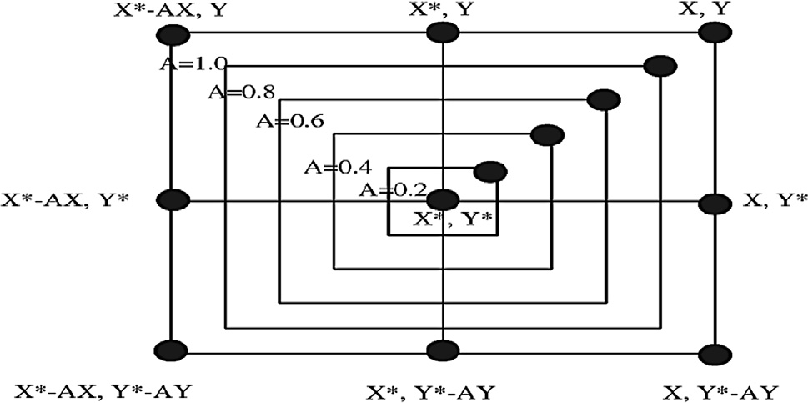

Fig. 1. Bubble net searching mechanism to update the position.

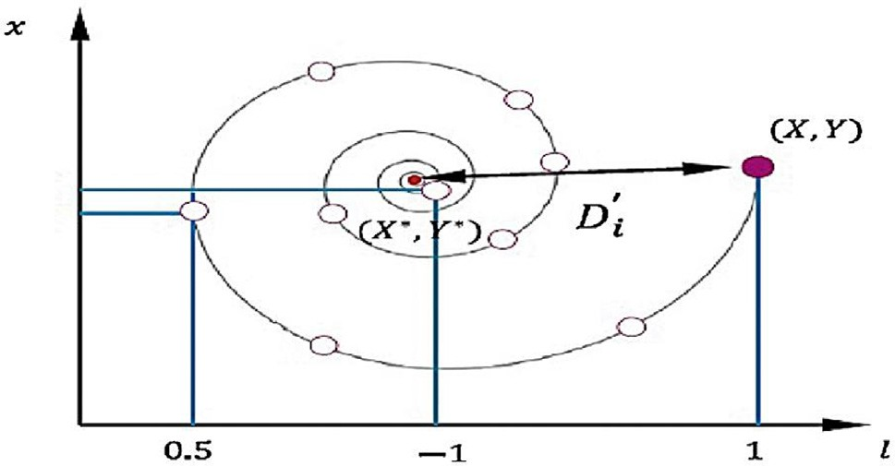

Fig. 2. Spiral. Searching Mechanism to update the position.

1. Build the Optimizer through generated the initial popula- tions of lions, determined the main positions of each lion and the main distances among lions and goal then consider this distance as fitness of that lions, sort the lions based on their fitness.
2. Develop the Lion Optimization Algorithm (LOA) by replacing the kernel of LOA in searching machnizam by using a smart feature (i.e., spirally searching & Bubble net searching) to increase the accuracy, at the same time reduce the execution time to reach of the goal.
3. Each lion based on step D will move from the recent position forward new sub goal as attempting to reach of the final goal, therefore, all lions need to update the positions and fit- ness of it. The main purpose of this step is determining lion active or more yauld, this step achieved through yauld feature.
4. To start by generated the proteins, we can’t work on the main DNA sequence therefore in A cooperative step, we will first generated mRNA molecules through; Build-mRNA-for- each-gene Then Build-protein-from- mRNA. Finally, Build- tRNA-for- protein after split it into triplet.
5. Apply four rules through synthesis each triplet tRNA to gen- erated proteins by Lion-AYAD optimization Algorithm this achieved final feature add by that algorithm that depend on deep composite that satisfy the rules.

* Rules for all triplets have the 2nd position is U generated set of

Proteins.

* Rules for all triplets have the 2nd position is C generated set of Proteins.
* Rules for all triplets have the 3rd position is A generated set of Proteins.
* Rules for all triplets have the 4th position is G generated set of Proteins.

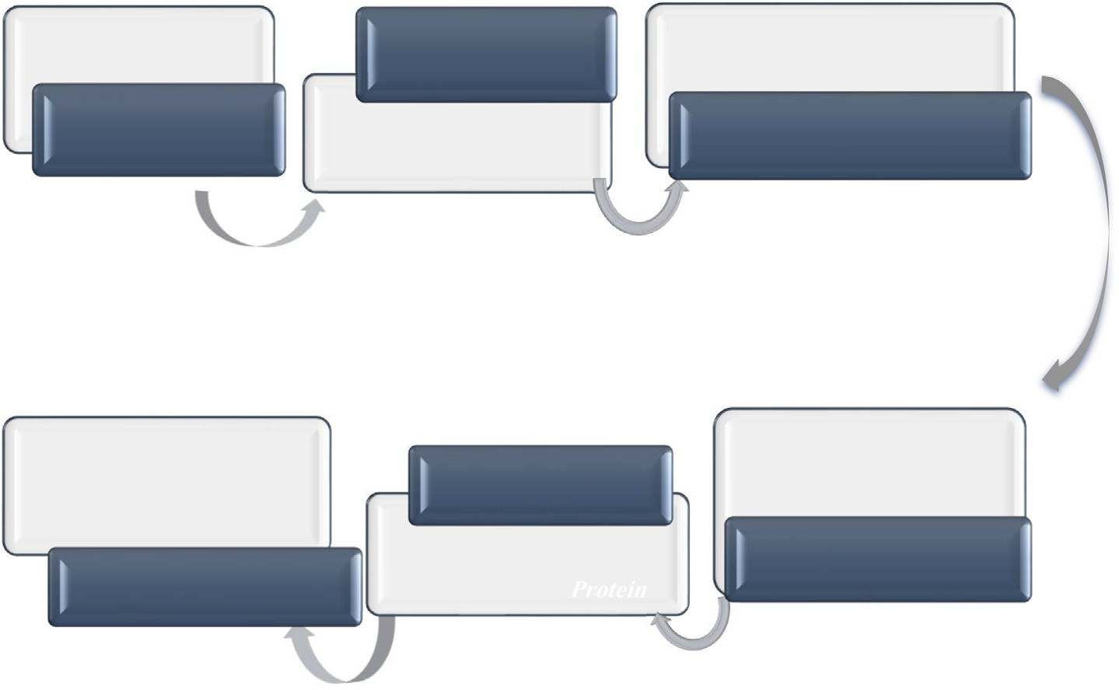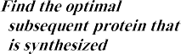

Fig. 3. Main Activities to A Novel Optimization Algorithm.

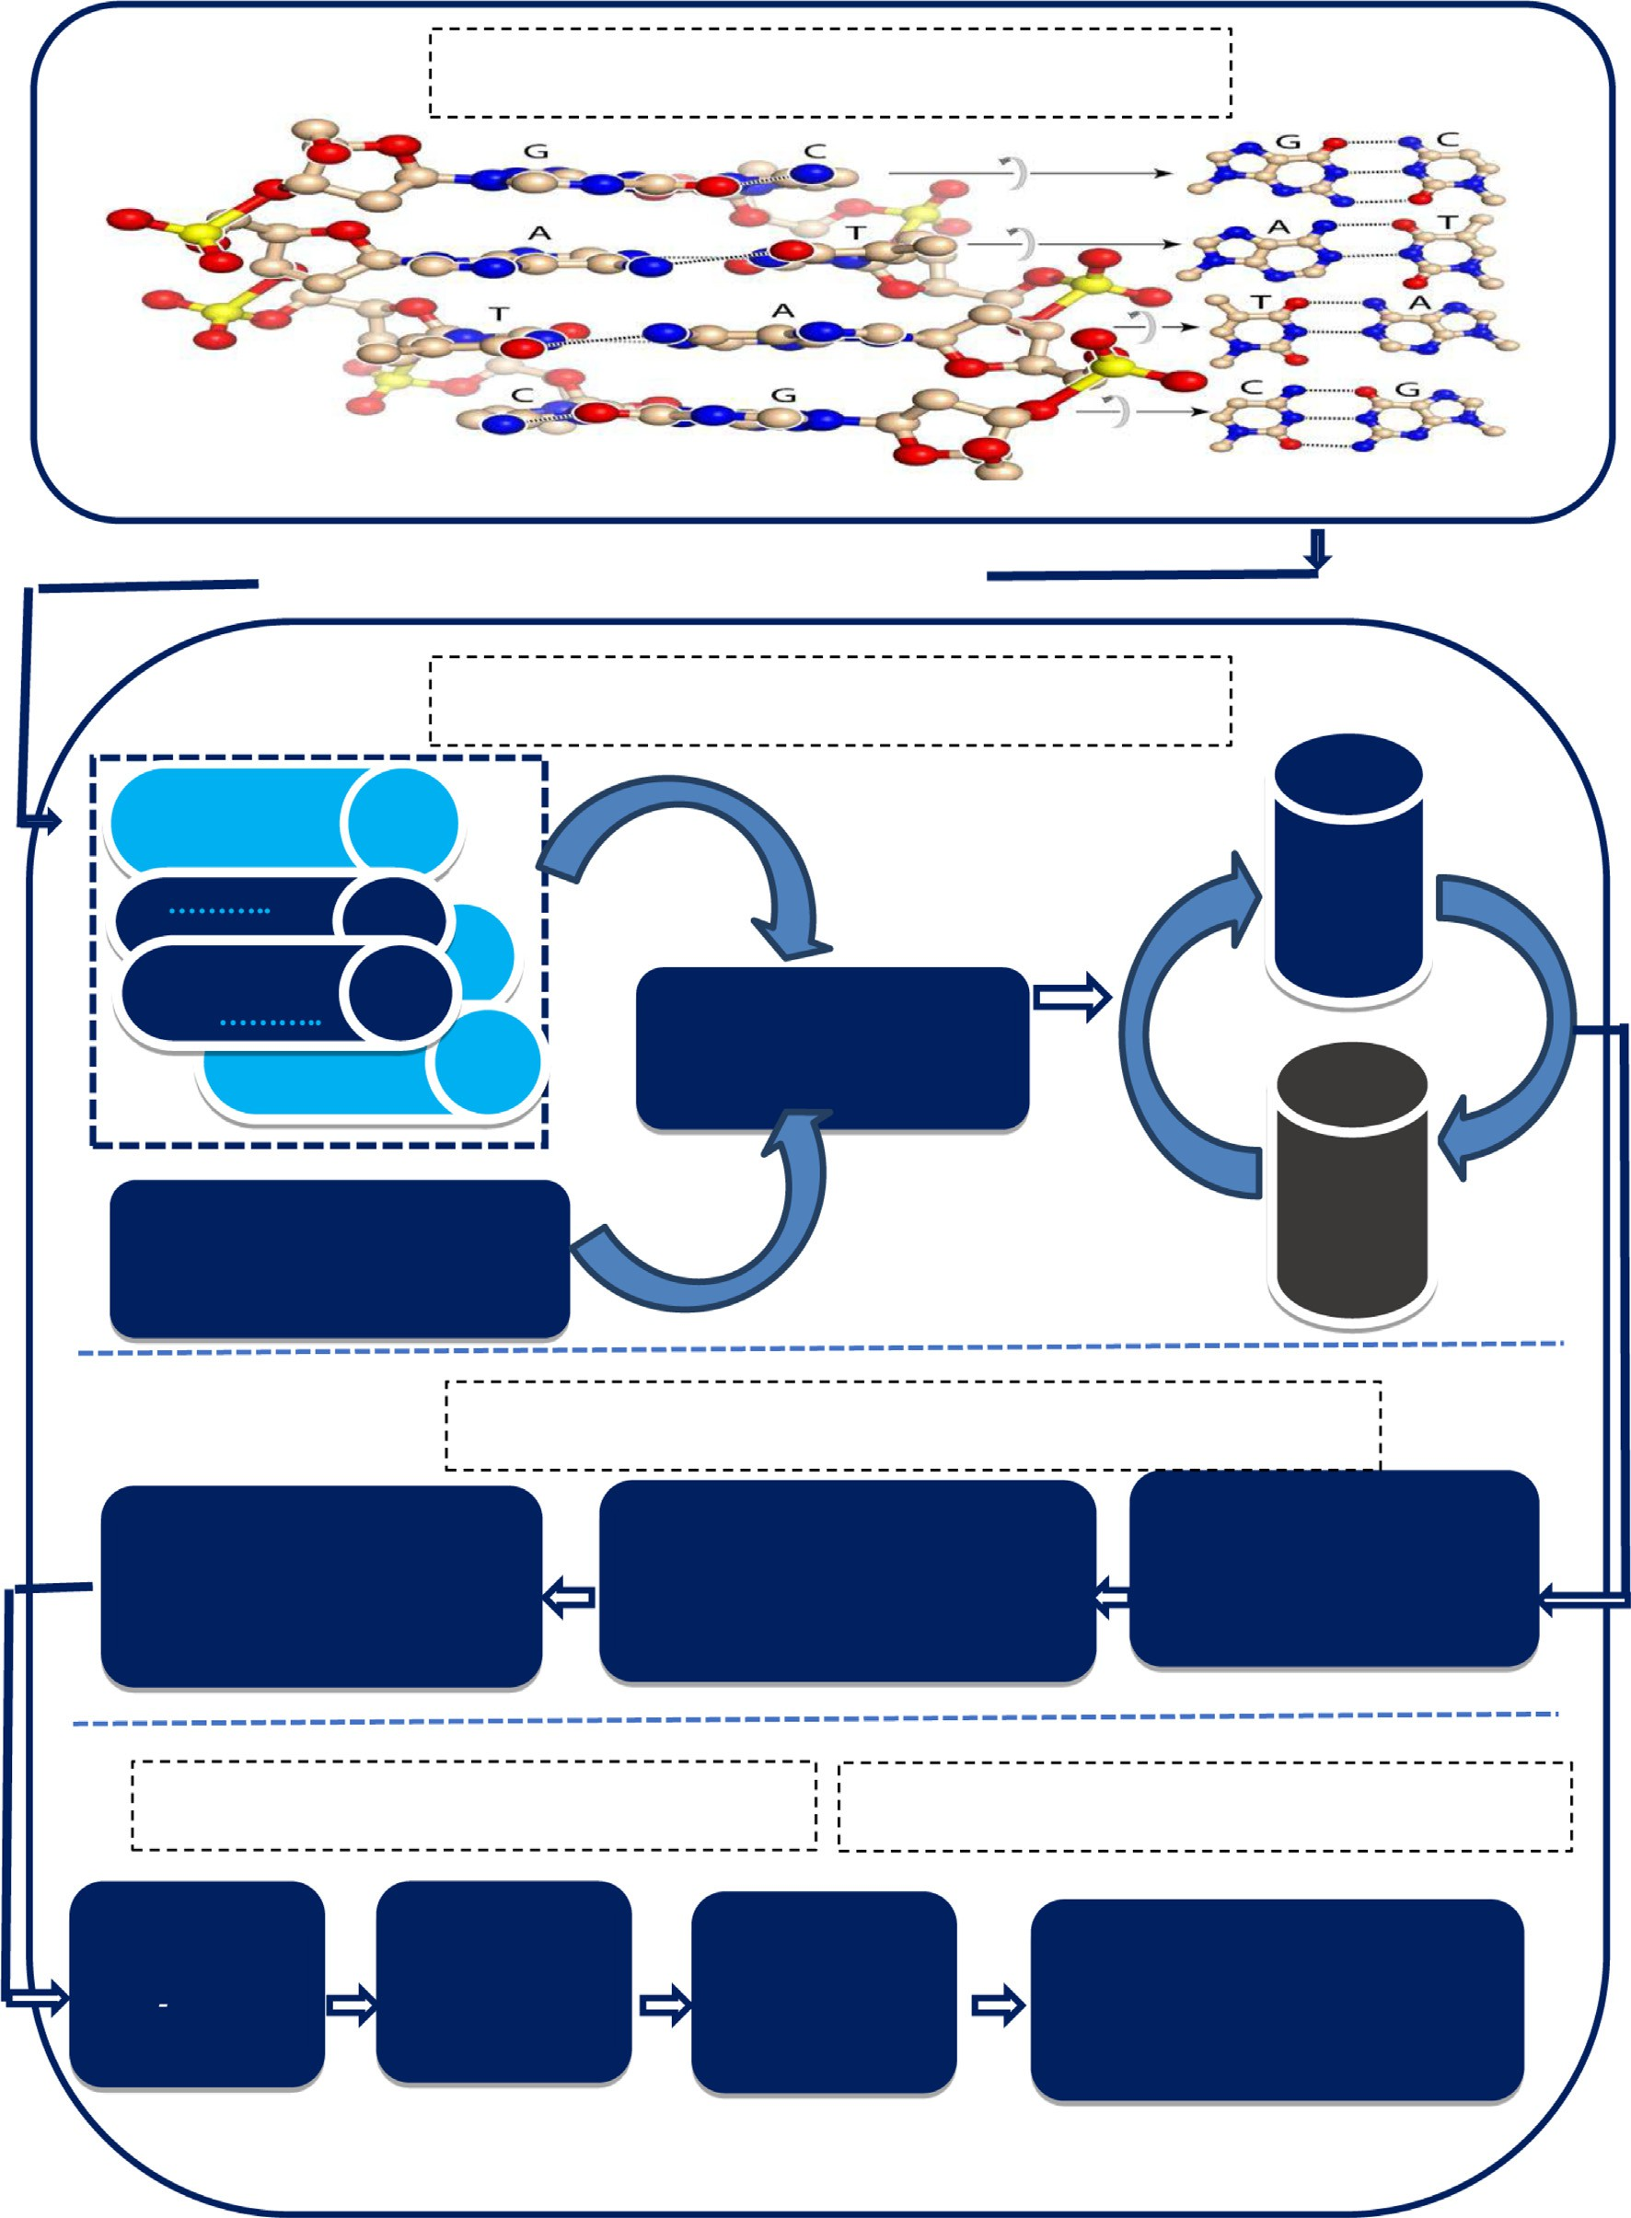

Fig. 4. The Architecture of Lion-AYAD.

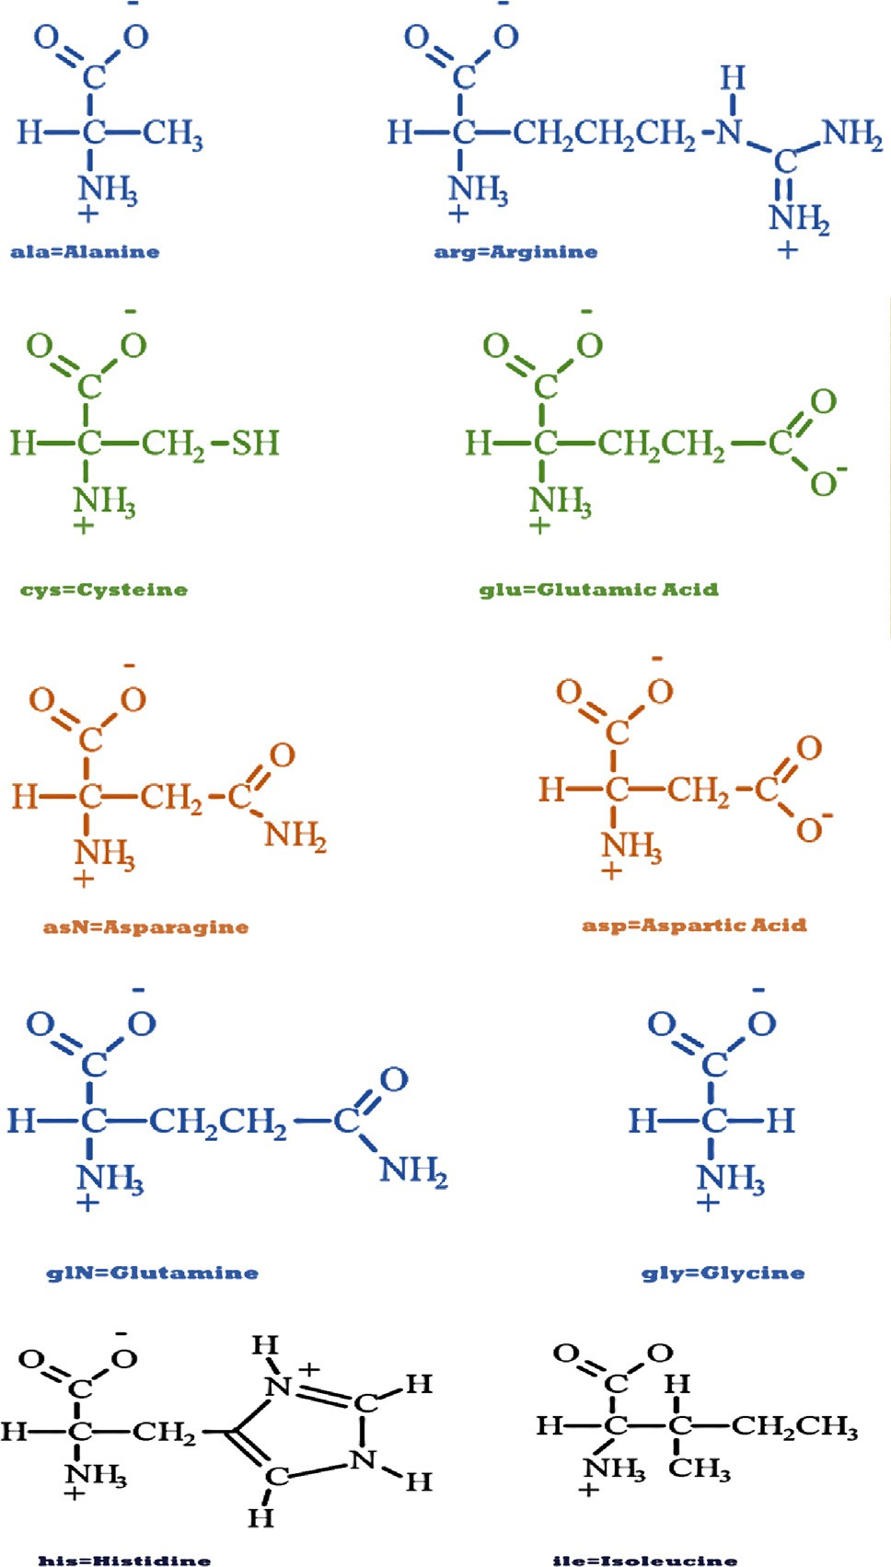

Fig. 5. Contribution of each triple concentrations in generation the 20 types of Proteins.

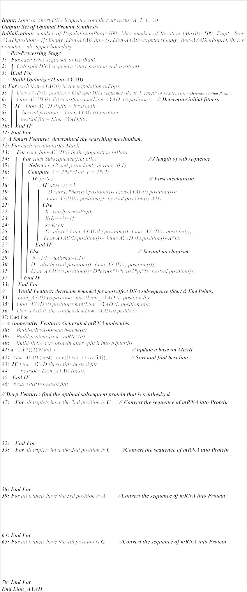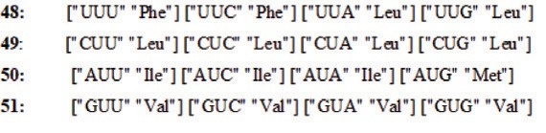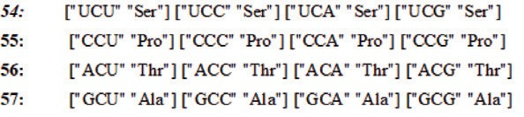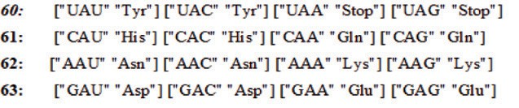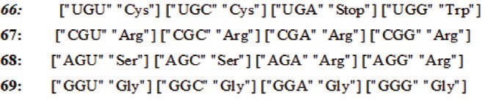

1. Results

To test the performance and behaviours of Lion-AYAD algo- rithm, we will take multi case studies different in the length of DNA sequence also show the types of proteins generated from each DNA sequence synthesis, the details of each case study will explain below in Fig. 6 and Fig. 7.

1. First Case Study: Implementation Lion-AYAD on Short Sequence of DNA
   * Proteins Produced from original DNA = 1: Protein: -Met-

Trp

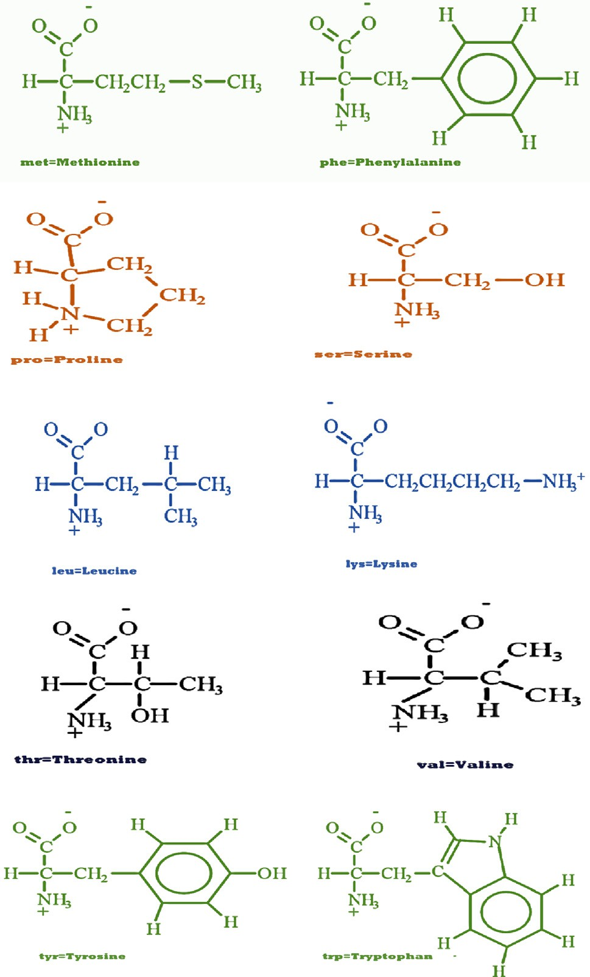

Fig. 5 (*continued*)

* + Proteins Produced from copy of DNA = 1: Protein: -Met- Trp

1. Second Case Study: Implementation Lion-AYAD on Sequence have one Cut Point

In this case study, we take the following an active sequence that have one start point represent in blue color is ATG and one end point represent in red color is TAG while the sequence is [GGGATG- GACACCTTATCATTTGCTACTAGCGACCAGTTTGAG

TAGCTTCGTCGGTGA]. This sequence contain *39* item and gener-

ated sequence of proteins contain *13* different types of proteins as shown in Table 2 through apply the main steps of lion-AYAD algorithm on the active sequence of DNA as represent in Fig. 8 (a, b,c,d,e,f, and g).

1. Third Case Study: Implementation Lion-AYAD on Sequence of DNA have Two Cut Points

In this case study, we get active a sequence has two start points represent in blue color are ATG and two end points represent in red color are TAG and TAA while a sequence is [AGTATGAAAACCCAC- GATGGTAGCCCGAGATTGAGATGTGGTTTTTCAGATAACAG]. This

active sequence contain 57 items while through apply Lion-AYAD algorithm on it generated two sequences of proteins, first contain *6* different types of proteins, second contain *5* different types of proteins as represent in Table 3 and Fig. 9 (a and b).

1. Fourth Case Study: Implementation Lion-AYAD Algorithm on Active Sequence of DNA have Three Cut Points

In this case study, we get active a sequence has three start points represent in blue color are ATG and three end points repre- sent in red color are TAG and TAA while a sequence is [GATATGTGGTAGCCCGAGATGTGGTTTTTCAGATAACAGATGTG-

GAGCAGCTTTTAG]. This active sequence contain 57 items while through apply Lion-AYAD algorithm on it generated three sequences of proteins, Table 4 described that proteins that distrib- uted as (2 types in first group, 5 in second group while 5 different types of proteins in third group). Fig. 10 (a and b) show all details.



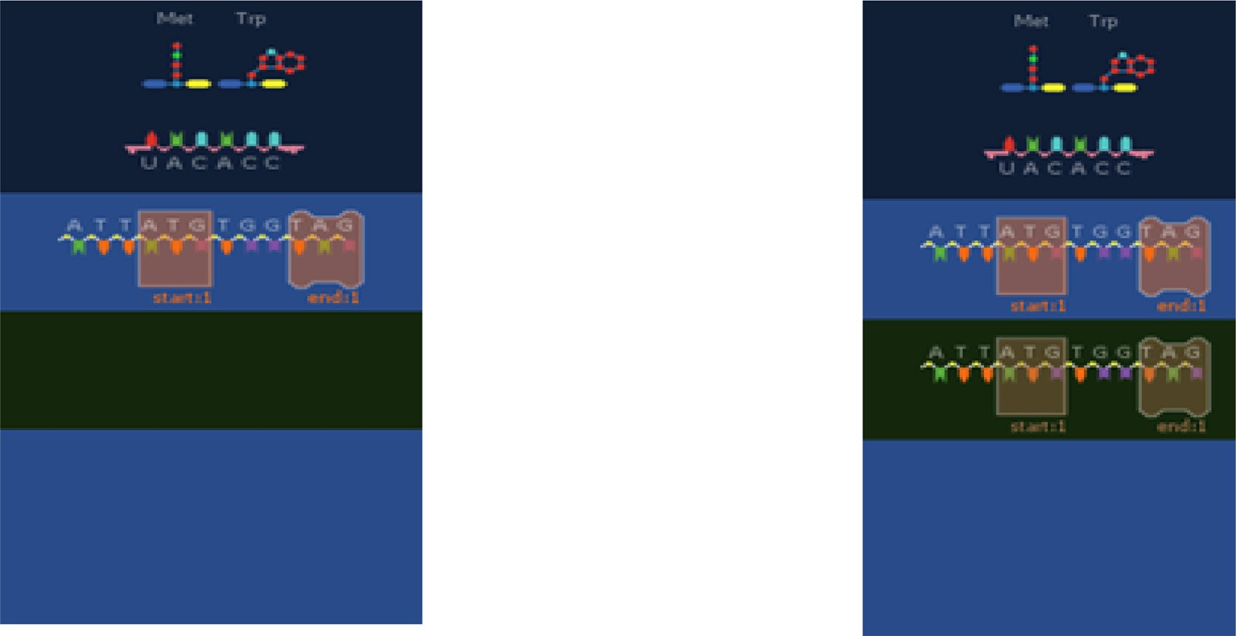

Fig. 6. Generate the proteins from short sequence [ATTATGTGGTAG].

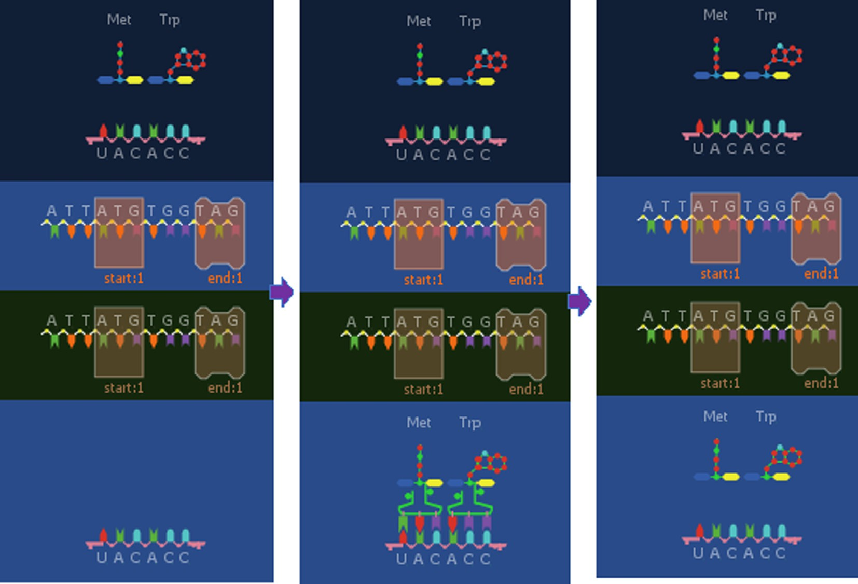

Fig. 7. Short sequence generated two proteins Met and Trp.

Table 2

Proteins generated base on Second Case Study.

1. Discussion & conclusion

This paper present multi points can be summarization as; A

Proteins Produced from original DNA = 1

Protein gen #1 -Met-Asp-Thr-Leu- Ser-Phe-Ala-Thr-Ser-Asp-Gln- Phe-Glu

Proteins Produced from copy of DNA = 1

Protein gen #1 -Met-Asp-Thr-Leu- Ser-Phe-Ala-Thr-Ser-Asp-Gln-Phe- Glu

novel approach for generate proteins using DNA Sequence Synthe- sis. Implies enhanced searching mechanism in the lion optimiza- tion algorithm. Incorporating four new features called ‘‘AYAD” with Lion optimization algorithm lead to increase statistical per- formance. The best results in term of generate proteins includes only calling behavior of four new features. Optimal lion-AYAD find

1. Fifth Case Study: Implementation Lion-AYAD Algorithm on Active Sequence of DNA have Eight Cut Points

In this case study, we get active a sequence has eight start and end points; a sequence is [GGGATGGACACCTTAT CATTTGCTAC TAGCGACCAGTTTGAGTAGCTTCGTCGGTGAATTTGGCACACAT GACTGGGAATGACCCCATTGACCCAGACGTGGTTTTTGAGTGGTGT TATGAGGGGGACCCGAGATGTGGTTTTTGAAATAGACAAGTAGACCC TAATAGACAGTATGAAAACCCACGAGTGGTAGCCCGAGATTGA

GATGTGGTTTTTCAGATAACAG]. This active sequence contain *297*

items while through apply Lion-AYAD algorithm on it generated eight sequences of proteins, these eight sequences contain *99* pro- teins distributed among *8 groups* especially *(13,25,5,26,13,5,6, and 5)* different types of proteins as explain in Table 5. While all steps shown in Fig. 11 (a,and b).

best behavior to generate all truth proteins from DNA sequence.

Before summarization the main features and characteristic of that algorithm will analysis traditional optimization algorithms based on the four points (i.e., advantages, disadvantages, primary parameters and Secondary parameters) compare with the algo- rithm called Lion-AYAD present in that work, in general, optimiza- tion tries to solve a variety of problems by producing many technical works to find optimal or reasonable solutions for a speci- fic problem. In this section, the major properties of five optimiza- tion algorithms have been considered and a comparison among them is shown in Table 6.

After that, we analyzed the main parameters of each optimiza- tion algorithm with the novel algorithm (lion-AYAD), where each one of the optimization algorithms has a number of parameters that can be primary factors in building the optimization model or

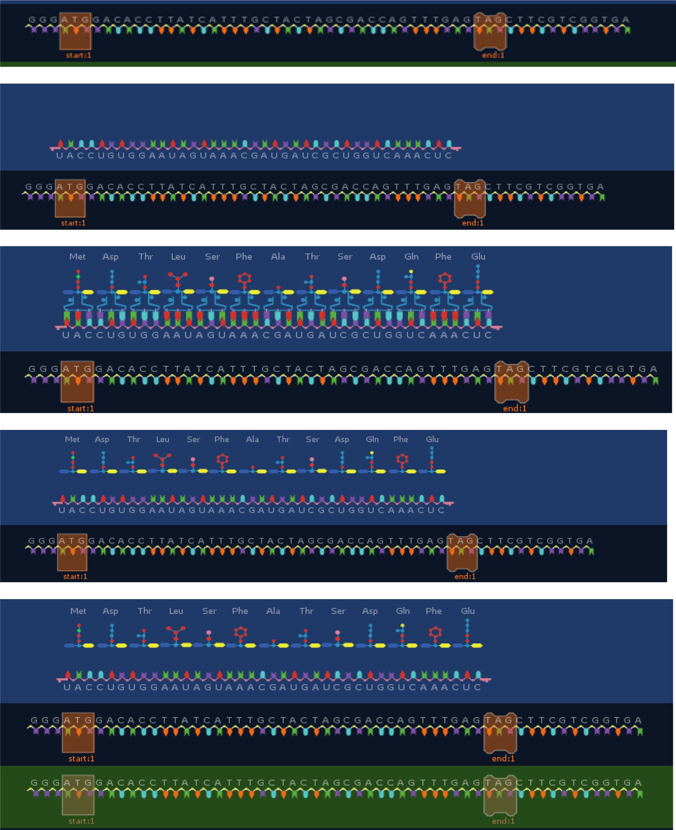

Fig. 8. Main Steps of Proteins generated through Lion-AYAD Algorithm.

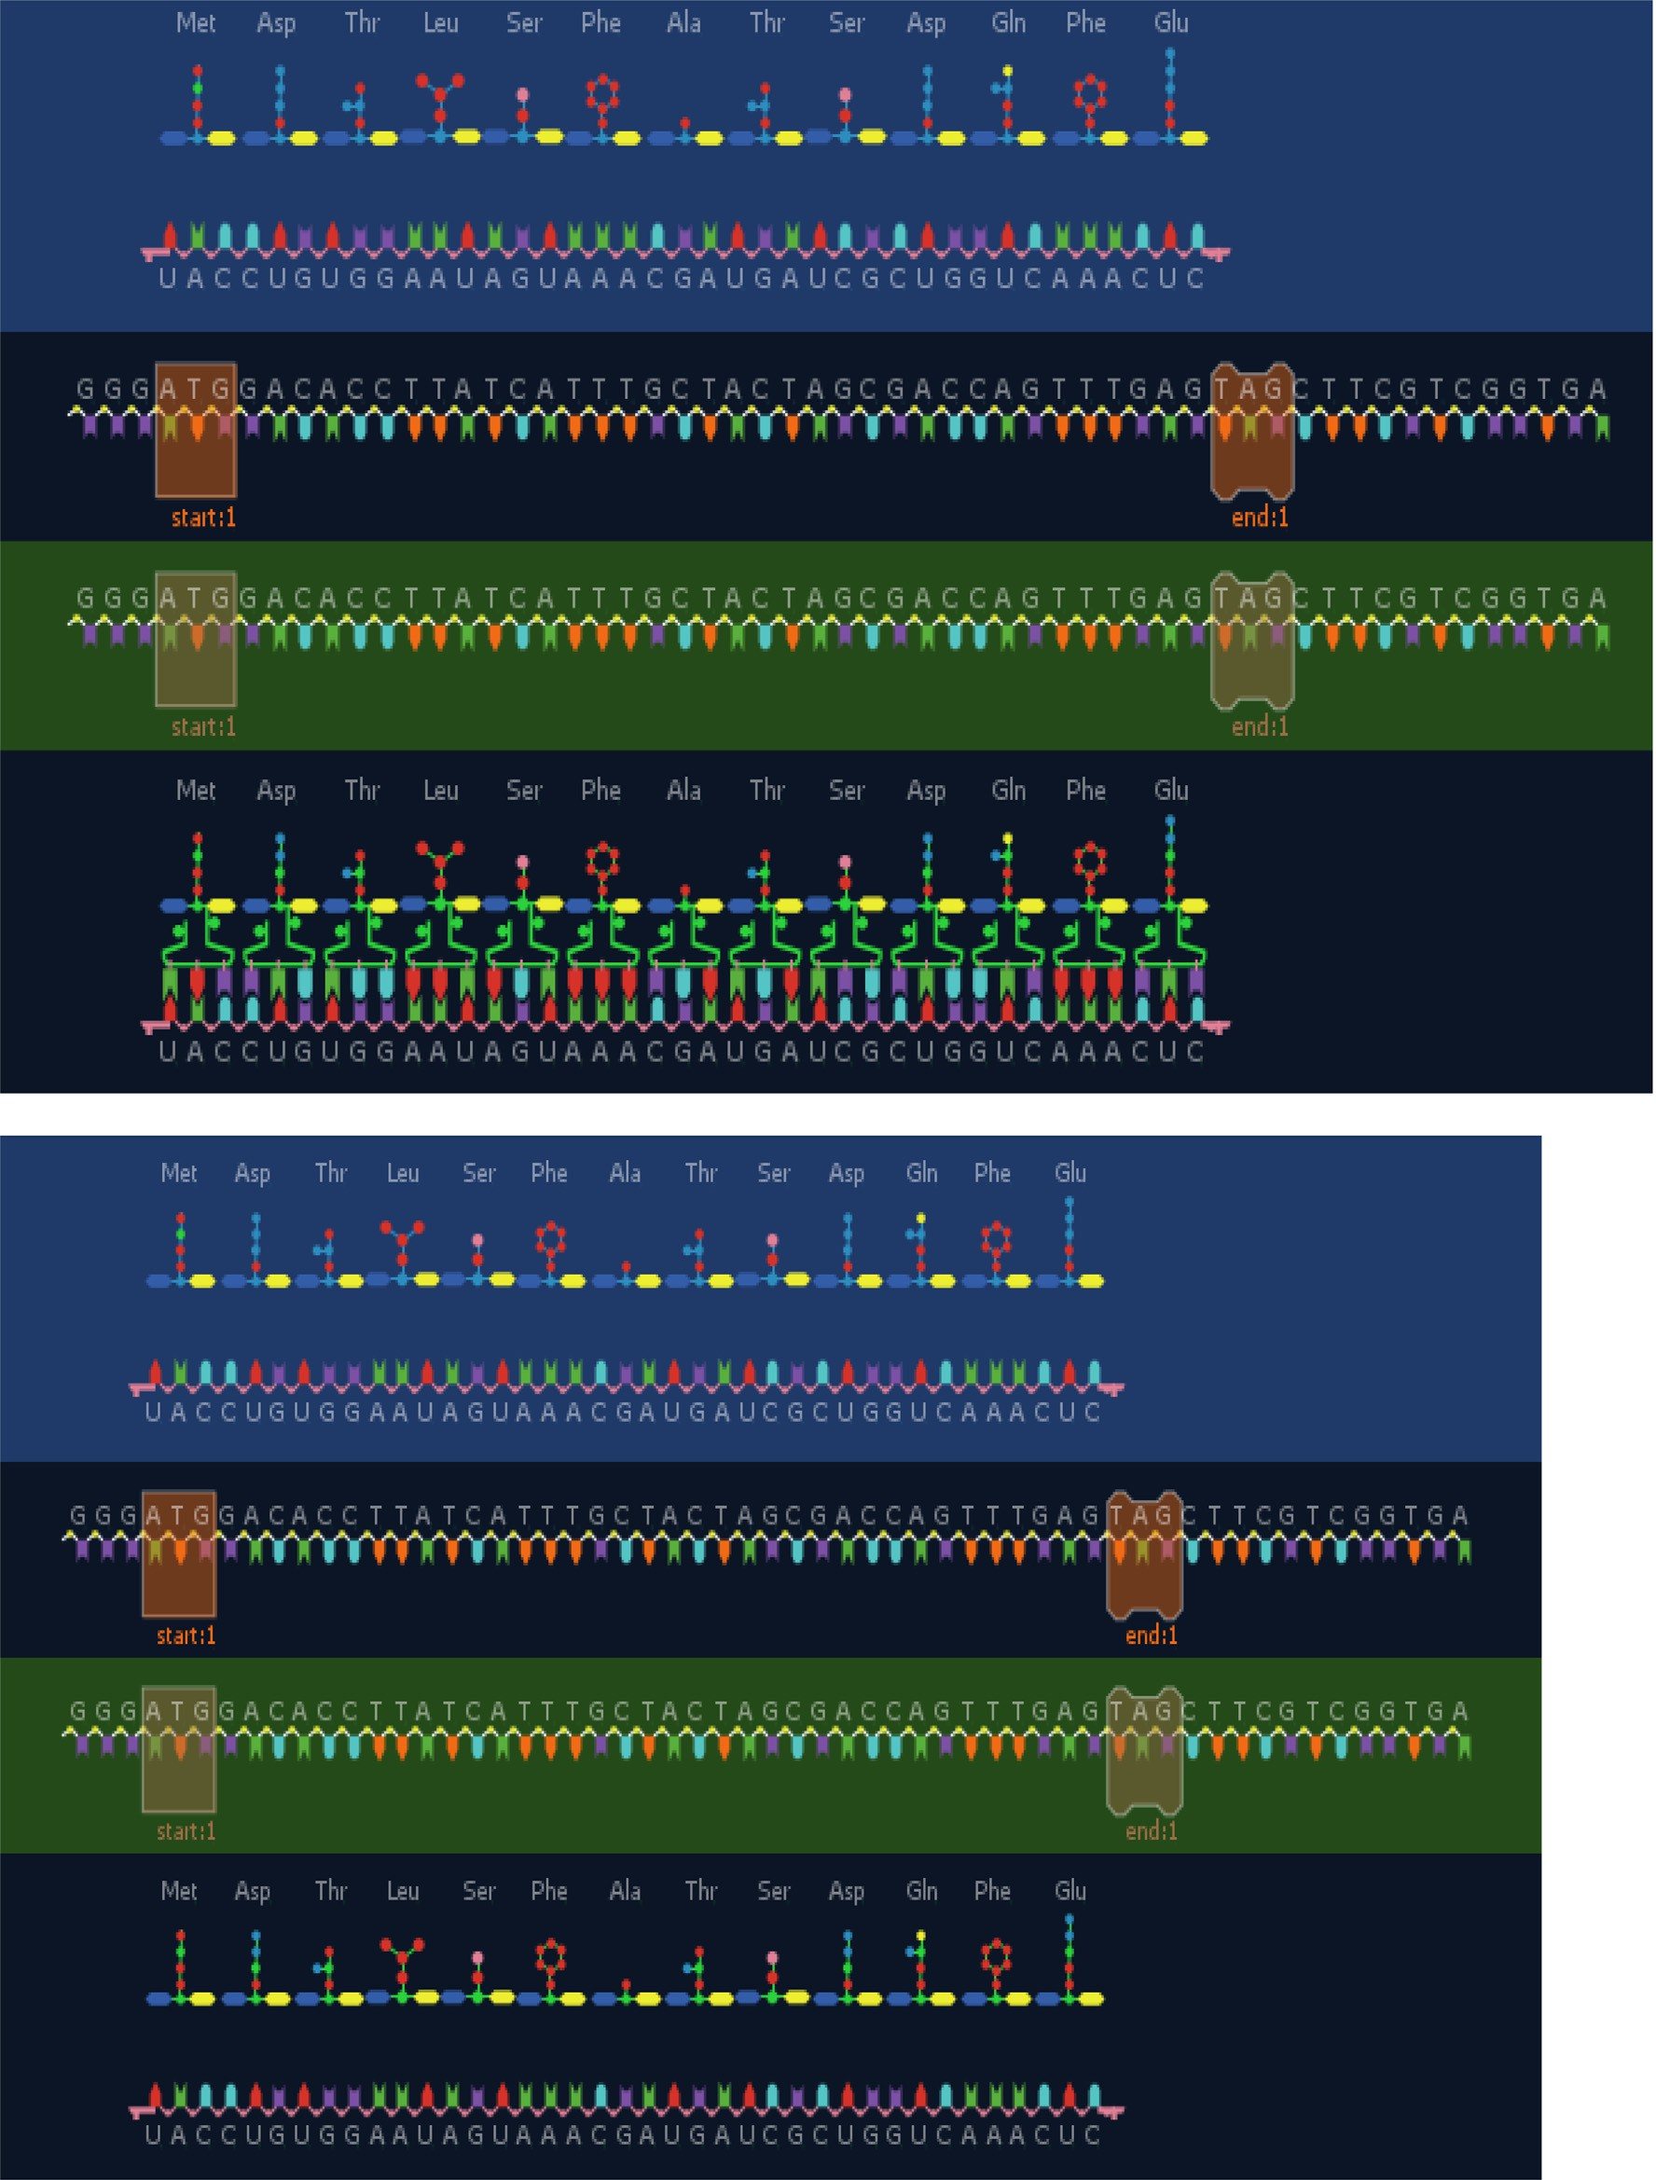

Fig. 8 (*continued*)

Table 3

Proteins generated base on Third Case Study.

Proteins Produced from original DNA = 2 Proteins Produced from copy of DNA = 2

Protein gen #1 -Met-Lys-Thr-His-Glu-Trp Protein gen #1 -Met-Lys-Thr-His-Glu-Trp

Protein gen #2 -Met-Trp-Phe-Phe-Arg Protein gen #2 -Met-Trp-Phe-Phe-Arg

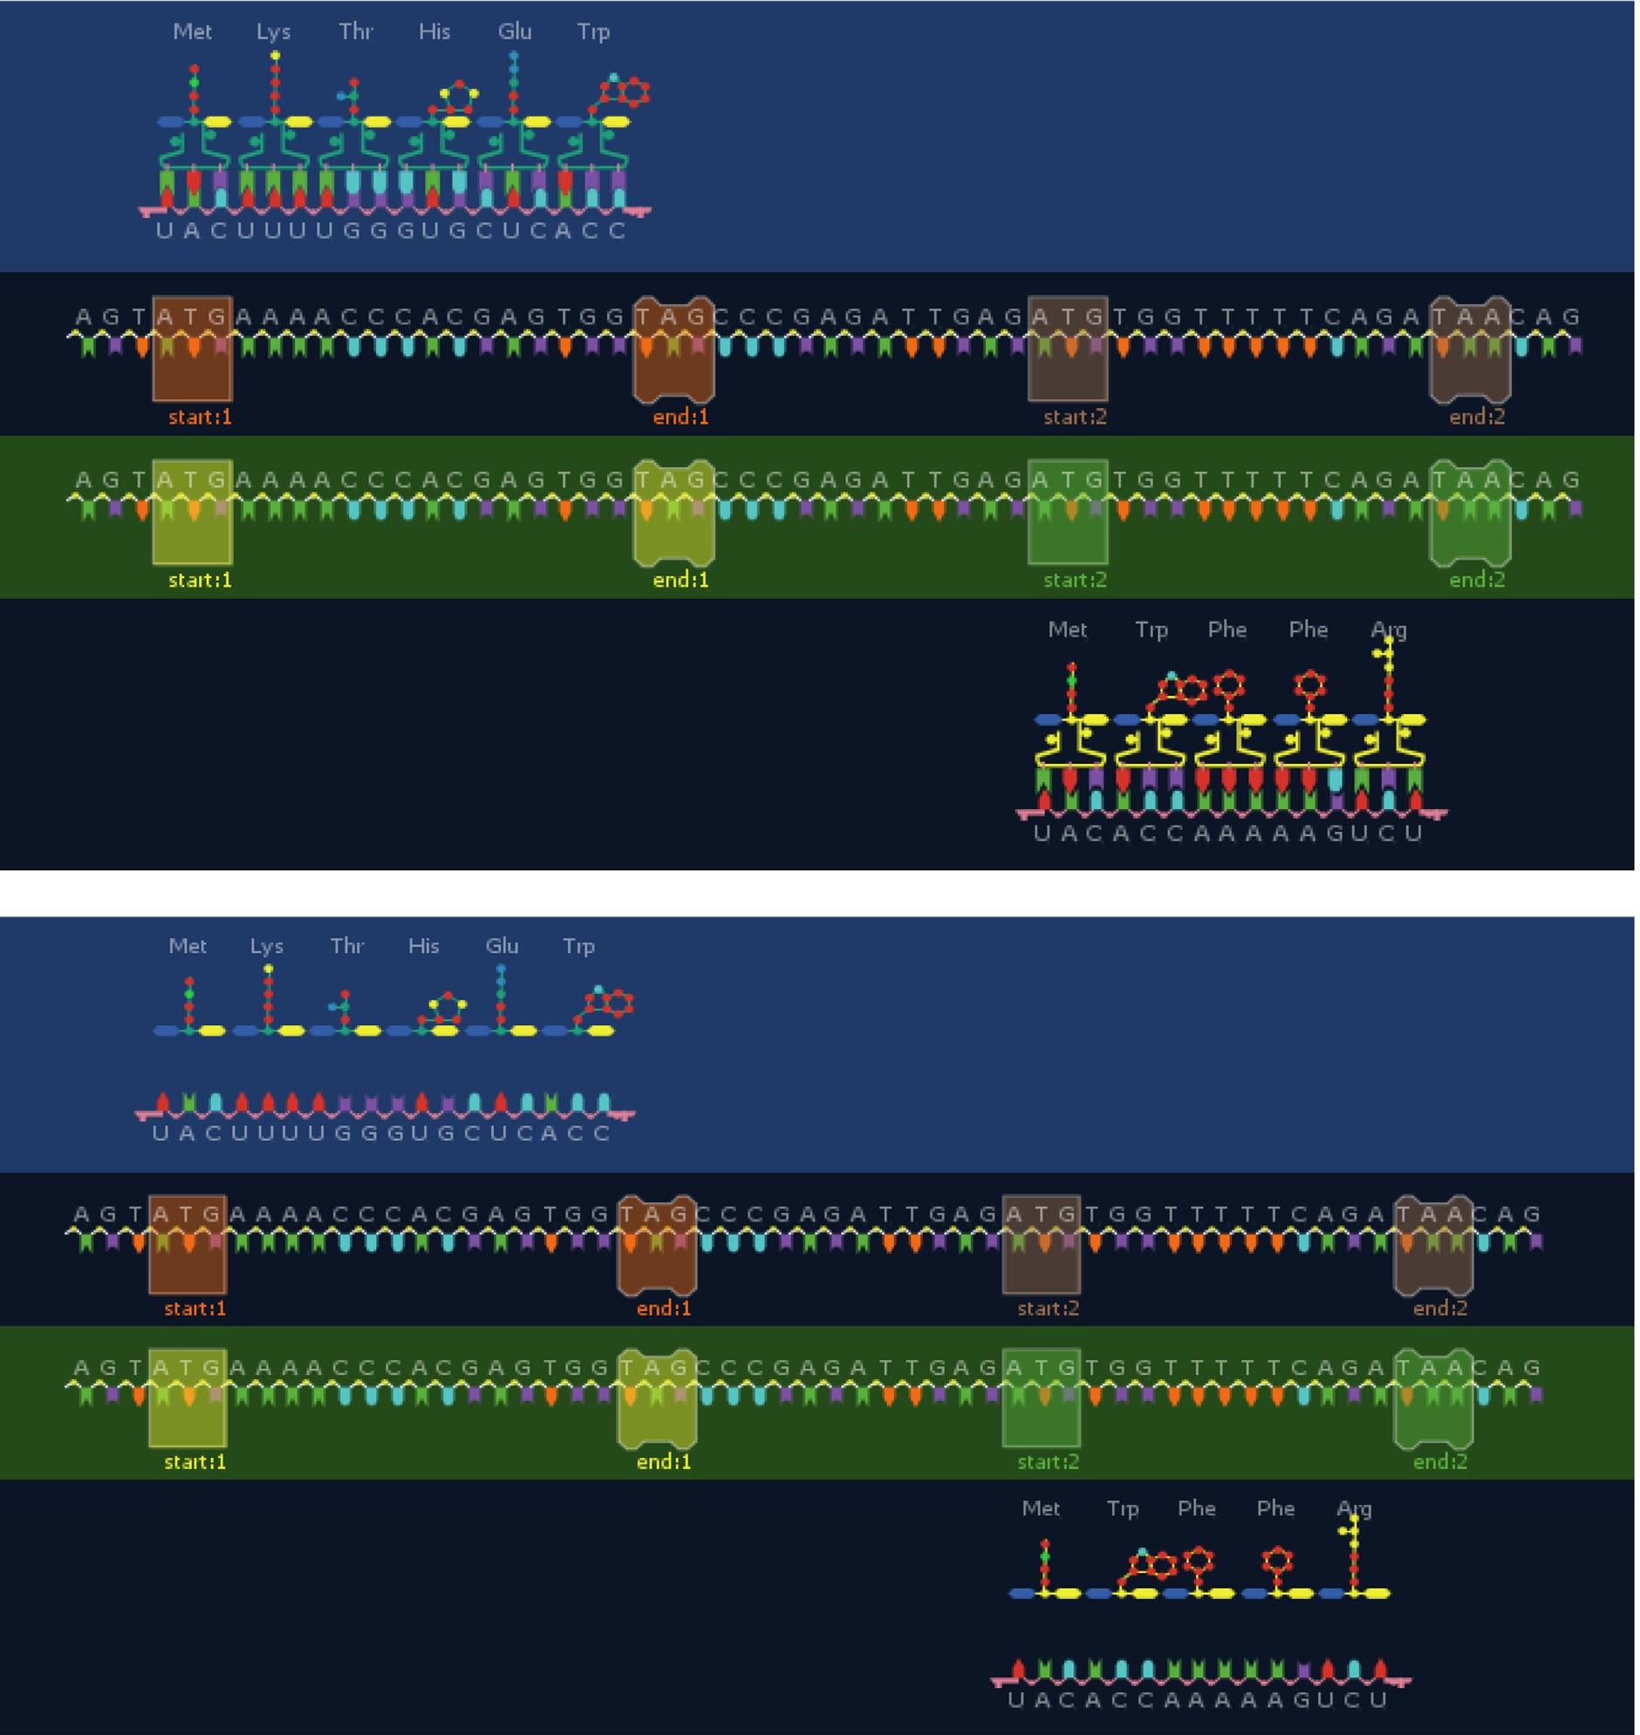





Fig. 9. Proteins generated by lion-AYAD from Active Sequence of DNA have two cut points.

Table 4

Proteins generated base on Fourth Case Study.

Proteins Produced from original DNA = 3 Proteins Produced from copy of DNA = 3

Protein gen #1: -Met-Trp Protein gen #1: -Met-Trp

Protein gen #2: -Met-Trp-Phe-Phe-Arg Protein gen #2: -Met-Trp-Phe-Phe-Arg

Protein gen #3: -Met-Trp-Ser-Ser-Phe Protein gen #3: -Met-Trp-Ser-Ser-Phe

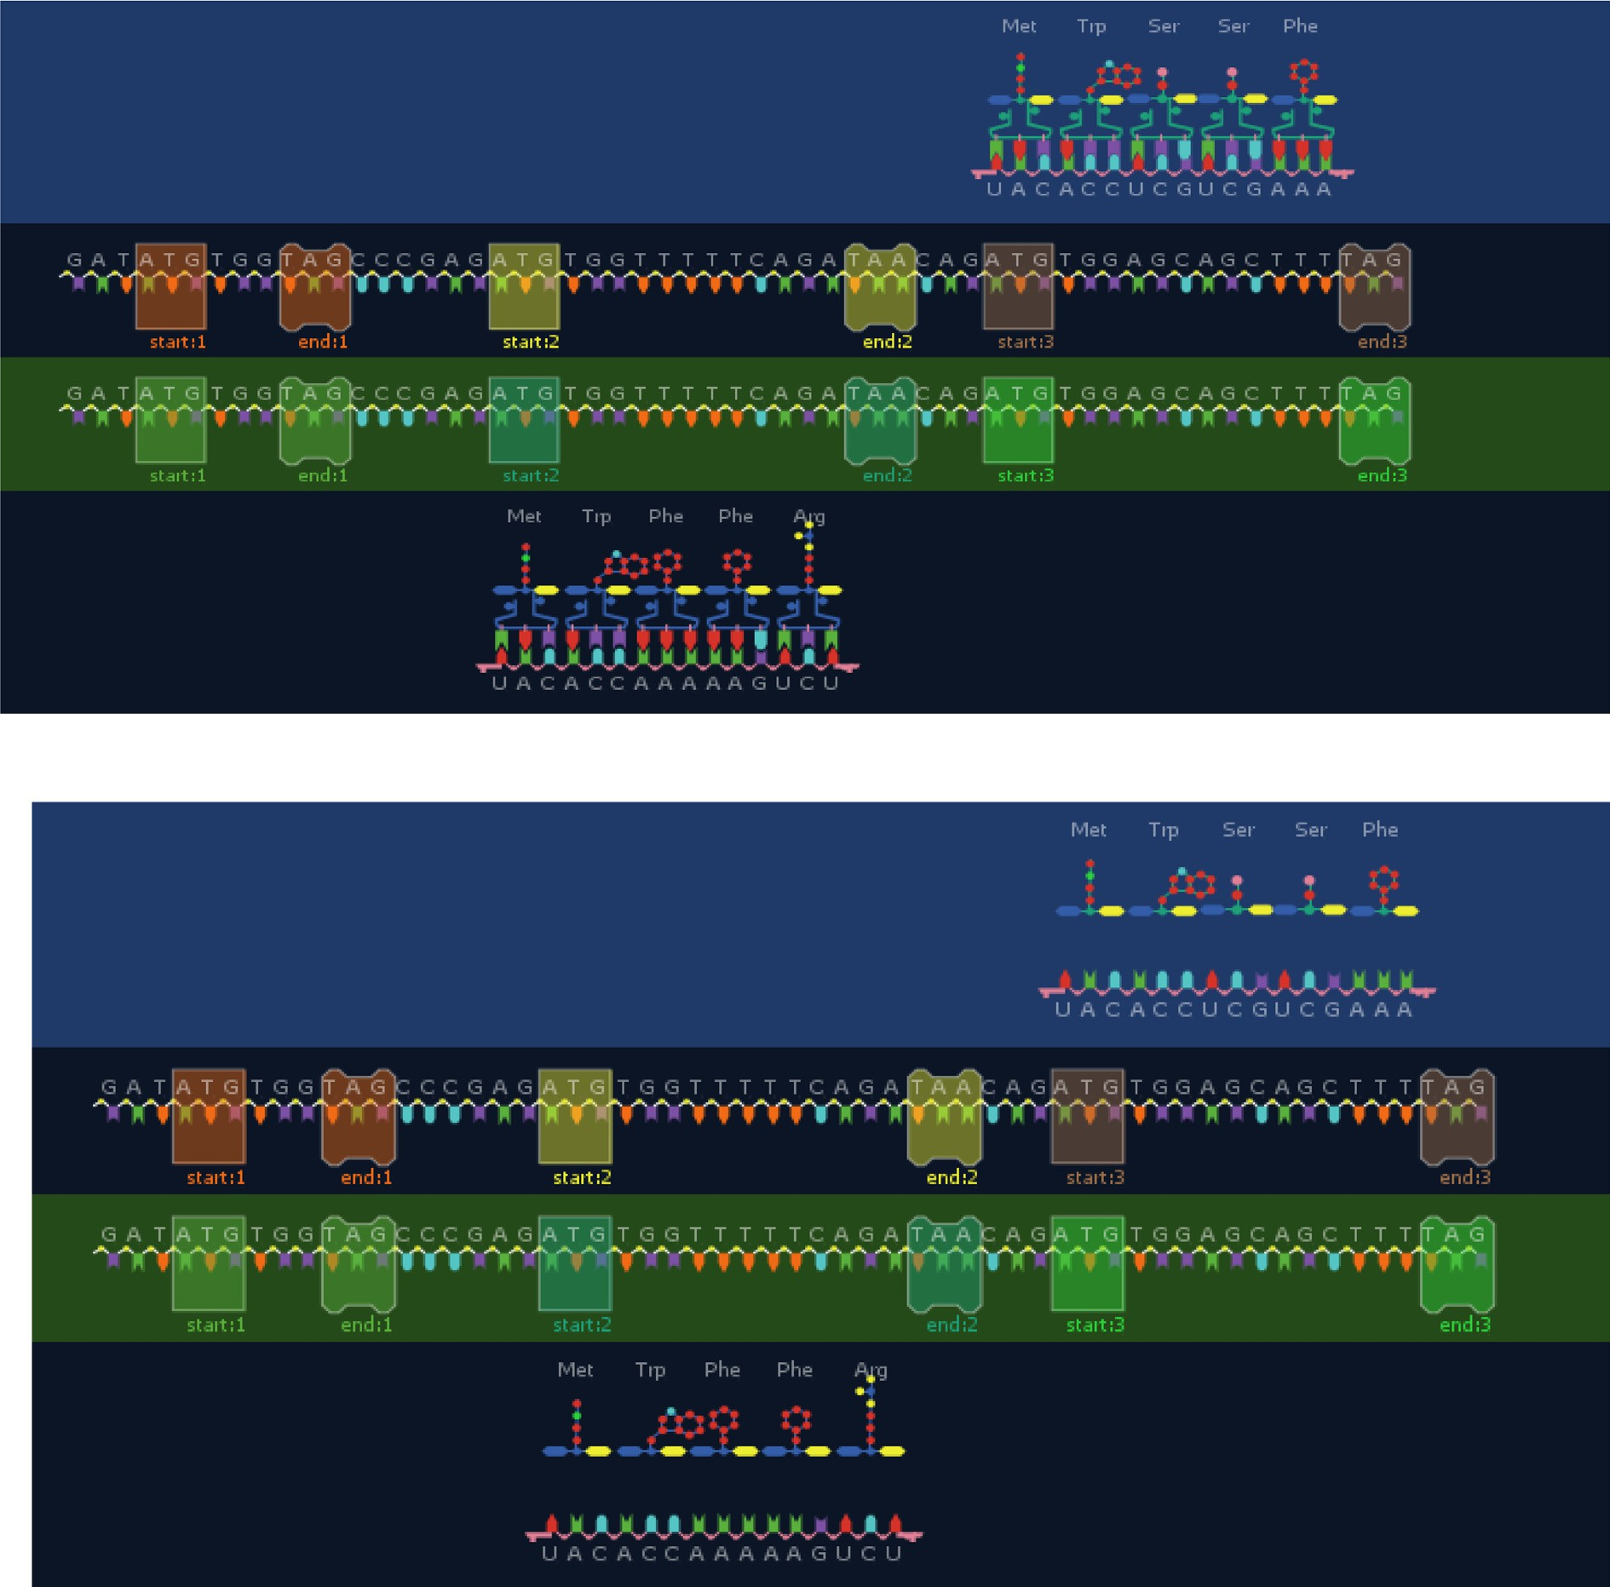

  

Fig. 10. Proteins generated by Lion-AYAD from Active Sequence of DNA has Three Cut Points.

Table 5a

Proteins generated base on Fifth Case Study.

Proteins Produced from original DNA = 8 Proteins Produced from copy of DNA = 8

Protein gen #1: -Met-Asp-Thr-Leu-Ser-Phe-Ala-Thr-Ser-Asp-Gln-Phe-Glu Protein gen #1: -Met-Asp-Thr-Leu-Ser-Phe-Ala-Thr-Ser-Asp-Gln-Phe-Glu

Protein gen #2: -Met-Thr-Gly-Asn-Asp-Pro-Ile-Asp-Pro-Asp-Val-Val-Phe-Glu- Trp-Cys-Tyr-Glu-Gly-Asp-Pro-Arg-Cys-Gly-Phe

Protein gen #2: -Met-Thr-Gly-Asn-Asp-Pro-Ile-Asp-Pro-Asp-Val-Val-Phe-Glu- Trp-Cys-Tyr-Glu-Gly-Asp-Pro-Arg-Cys-Gly-Phe

Protein gen #3: -Met-Trp-Phe-Phe-Arg Protein gen #3: -Met-Trp-Phe-Phe-Arg

Protein gen #4: -Met-Thr-Pro-Leu-Thr-Gln-Thr-Trp-Phe-Leu-Ser-Gly-Val-Met- Arg-Gly-Thr-Arg-Asp-Val-Val-Phe-Glu-Ile-Asp-Lys

Protein gen #4: -Met-Thr-Pro-Leu-Thr-Gln-Thr-Trp-Phe-Leu-Ser-Gly-Val-Met- Arg-Gly-Thr-Arg-Asp-Val-Val-Phe-Glu-Ile-Asp-Lys

Protein gen #5: -Met-Arg-Gly-Thr-Arg-Asp-Val-Val-Phe-Glu-Ile-Asp-Lys Protein gen #5: -Met-Arg-Gly-Thr-Arg-Asp-Val-Val-Phe-Glu-Ile-Asp-Lys

Protein gen #6:-Met-Trp-Phe-Leu-Lys Protein gen #6:-Met-Trp-Phe-Leu-Lys

Protein gen #7: -Met-Lys-Thr-His-Glu-Trp Protein gen #7: -Met-Lys-Thr-His-Glu-Trp

Protein gen #8: -Met-Trp-Phe-Phe-Arg Protein gen #8: -Met-Trp-Phe-Phe-Arg

Table 5b

Proteins generated base on Fifth Case Study.

Proteins Produced from original DNA = 8 Proteins Produced from copy of DNA = 8

Protein gen #1: -Met-Asp-Thr-Leu-Ser-Phe-Ala-Thr-Ser-Asp-Gln-Phe-Glu Protein gen #1: -Met-Asp-Thr-Leu-Ser-Phe-Ala-Thr-Ser-Asp-Gln-Phe-Glu

Protein gen #2: -Met-Thr-Gly-Asn-Asp-Pro-Ile-Asp-Pro-Asp-Val-Val-Phe-Glu- Trp-Cys-Tyr-Glu-Gly-Asp-Pro-Arg-Cys-Gly-Phe

Protein gen #2: -Met-Thr-Gly-Asn-Asp-Pro-Ile-Asp-Pro-Asp-Val-Val-Phe-Glu- Trp-Cys-Tyr-Glu-Gly-Asp-Pro-Arg-Cys-Gly-Phe

Protein gen #3: -Met-Trp-Phe-Phe-Arg Protein gen #3: -Met-Trp-Phe-Phe-Arg

Protein gen #4: -Met-Thr-Pro-Leu-Thr-Gln-Thr-Trp-Phe-Leu-Ser-Gly-Val-Met- Arg-Gly-Thr-Arg-Asp-Val-Val-Phe-Glu-Ile-Asp-Lys

Protein gen #4: -Met-Thr-Pro-Leu-Thr-Gln-Thr-Trp-Phe-Leu-Ser-Gly-Val-Met- Arg-Gly-Thr-Arg-Asp-Val-Val-Phe-Glu-Ile-Asp-Lys

Protein gen #5: -Met-Arg-Gly-Thr-Arg-Asp-Val-Val-Phe-Glu-Ile-Asp-Lys Protein gen #5: -Met-Arg-Gly-Thr-Arg-Asp-Val-Val-Phe-Glu-Ile-Asp-Lys

Protein gen #6:-Met-Trp-Phe-Leu-Lys Protein gen #6:-Met-Trp-Phe-Leu-Lys

Protein gen #7: -Met-Lys-Thr-His-Glu-Trp Protein gen #7: -Met-Lys-Thr-His-Glu-Trp

Protein gen #8: -Met-Trp-Phe-Phe-Arg Protein gen #8: -Met-Trp-Phe-Phe-Arg

Table 6

Comparison among Main optimization algorithms with Lion-AYAD.

Algorithm Advantages Disadvantages Primary parameters

Secondary Parameters

PSO ● Can be simple to implement

* Have few parameters to adjust
* Able to run parallel computation
* Can be robust
* Have higher probability and efficiency in finding the global optima
* Can converge fast
* Do not overlap and mutate
* Have short computational time
* Can be efficient for solving problems presenting difficulty to find accurate mathematical models

COA ● It satisfies the global convergence requirements.

* It supports local and global search capabilities .
* It uses Lévy flights as a global search strategy.
* Can be difficult to define initial design parameters
* Cannot work out the problems of scattering
* Can converge prematurely and be trapped into a local minimum especially with complex problems
* Algorithm is still undergoing rapid development and improve- ment, and the processing of some links still needs continuous

optimization

X,P*,Y* c1,c2,r1,r2

X,Y,F,N T

WOA ● has the ability to avoid local optima and get a glob-

ally optimal solution

* + appropriate for solving different constrained or unconstrained optimization problems for practical

applications

* + It has two types of motion are spiral and square
* not good at exploring the search space. X , Y, *C , A ,*

*D,F, Xrand*

t, n , p, a , r

,l , b

LOA ● The method of searching the solution area at ran-

dom and Avoid getting caught in your local Optima

* + The space of the solution arises exp with the prob- lem to be solved
  + It works to find and replace the worst solution with the best solutions.
  + The results of this algorithm confirm its high per- formance compared to other optimization

algorithms.

* The search space may be large and therefore it takes more time

to find the best solution.

Npop, X, Y, F, S

M, UB, LB

Lion-

AYAD

* Dynamic machnizam can work with different

length of sequence (small, middle and long

sequence)

* Reduce the time complexity for find optimal protein
* High accuracy because in each step fined optimal solution before move to the next steps
* Add the new four features of lion make it more robust
* Need more computation
* Remined need from user determine the start of sequence

X , Y, *C , A ,*

*D,F, Xrand*

M, UB, LB

Where X is input dataset, Y is the goal, F is the activation function, N is the number of nests, and T number of iteration, W is weights, Jc is Jumping constant, E is error ratio, Npop number of population, S is seed, M is mating, UB is upper dimensions, LB is the lower dimensions, Xrand = randomly selected solution vector, C & A is coefficient vectors, D is the direction of motion, t is current iteration, r is the random vector, a is the vector decreasing from 2 to 0 throughout the iteration, p is the probability of motion, spiral or

square, b is the logarithmic spiral constant, and l is the random number in the range [—1, 1]

Table 7

Main Parameters effect on optimization techniques.

Algorithm Parameters

|  |  |  |  |  |  |  |  |  |  |  |  |  |  |  |  |  |  |  |  |  |  |  |  |  |  |  |  |  |  |  |
| --- | --- | --- | --- | --- | --- | --- | --- | --- | --- | --- | --- | --- | --- | --- | --- | --- | --- | --- | --- | --- | --- | --- | --- | --- | --- | --- | --- | --- | --- | --- |
|  | X | Y | F | N | T | W | Jc | E | Npop | S | M | UB | LB | C | A | D | Xrand | t | n | p | a | r | l | p | r1 | r2 | c1 | C2 | Po |  |
| PSO |  |  | × | × | × | × | × | × | × | × | × | × | × | × | × | × | × | × | × | × | × | × | × | × | U | U | U | U | U |  |
| COA |  |  |  |  |  | × | × | × | × | × | × | × | × | × | × | × | × | × | × | × | × | × | × | × | × | × | × | × | × |  |
| WOA |  |  | U | × | U | × | × | × | × | × | × | × | × | U | U | U | U | U | U | U | U | U | U | U | × | × | × | × | × |  |
| LOA |  |  | U | × | × | × | × | × | U | U | U | U | U | × | × | × | × | × | × | × | × | × | × | × | × | × | × | × | × |  |
| LION-AYAD |  |  | × | U | × | U | × | U | U | U | U | U | U | × | × | × | × | × | × | × | × | × | U | U | U | U | × | × | × |  |

Table 8

Comparison among the evaluation measures, which affect Optimization Techniques.

|  |  |  |  |  |  |
| --- | --- | --- | --- | --- | --- |
| Evaluation-Measures | PSO | COA | WOA | LOA | LION-AYAD |
| Accuracy | 84.87% | 72.89% | 91.54% | 90.01% | 92.51% |
| True positive (TP) | 86% | 81% | 88% | 87% | 89% |
| Precision | 97% | 83% | 92% | 93% | 91% |
| Recall | 91.16% | 77.19% | 89.81% | 84.81% | 82.21% |
| F-Measure | 93.58% | 83.61% | 93.82% | 95.23% | 97.79% |



Fig. 11. Proteins generated by active DNA Sequence have eight Cut Points.

it can be secondary ones, which contribute to the primary param- eters to provide an optimum solution. That used to build a new Lion-AYAD optimizer, it is necessary to analyze these parameters and make the comparison for the presence and absence of each one to determine their effects in the optimization techniques. Table 7 shows compression between optimization techniques parameters.

As a results, we can summarized the main advantages of Lion- AYAD is the dynamic of application on different length of sequence this meaning the length of sequence become dynamic where the algorithm can work on small, middle and long sequence, also the determined the active sequence from multi sequence become

achieved automatically through the first features of the algorithm, the algorithm in each steps searching the short path to transform from the start point to goal and the lions move through sequence of sub-goals by search on the best position before travelling to it this satisfy by the second features of the algorithm. Generating mRNA molecules for the active sequence of DNA (i.e., lion have best value fitness determined through second features of that algo- rithm) through; Build mRNA for each gene (i.e., move in specific region known the start and end point of it) Then Build protein from mRNA Finally, Build tRNA for protein after split it into triplet this achieved by add the third properties to algorithm under title coop- erative. How can synthesis each triple of tRNA to generated pro-

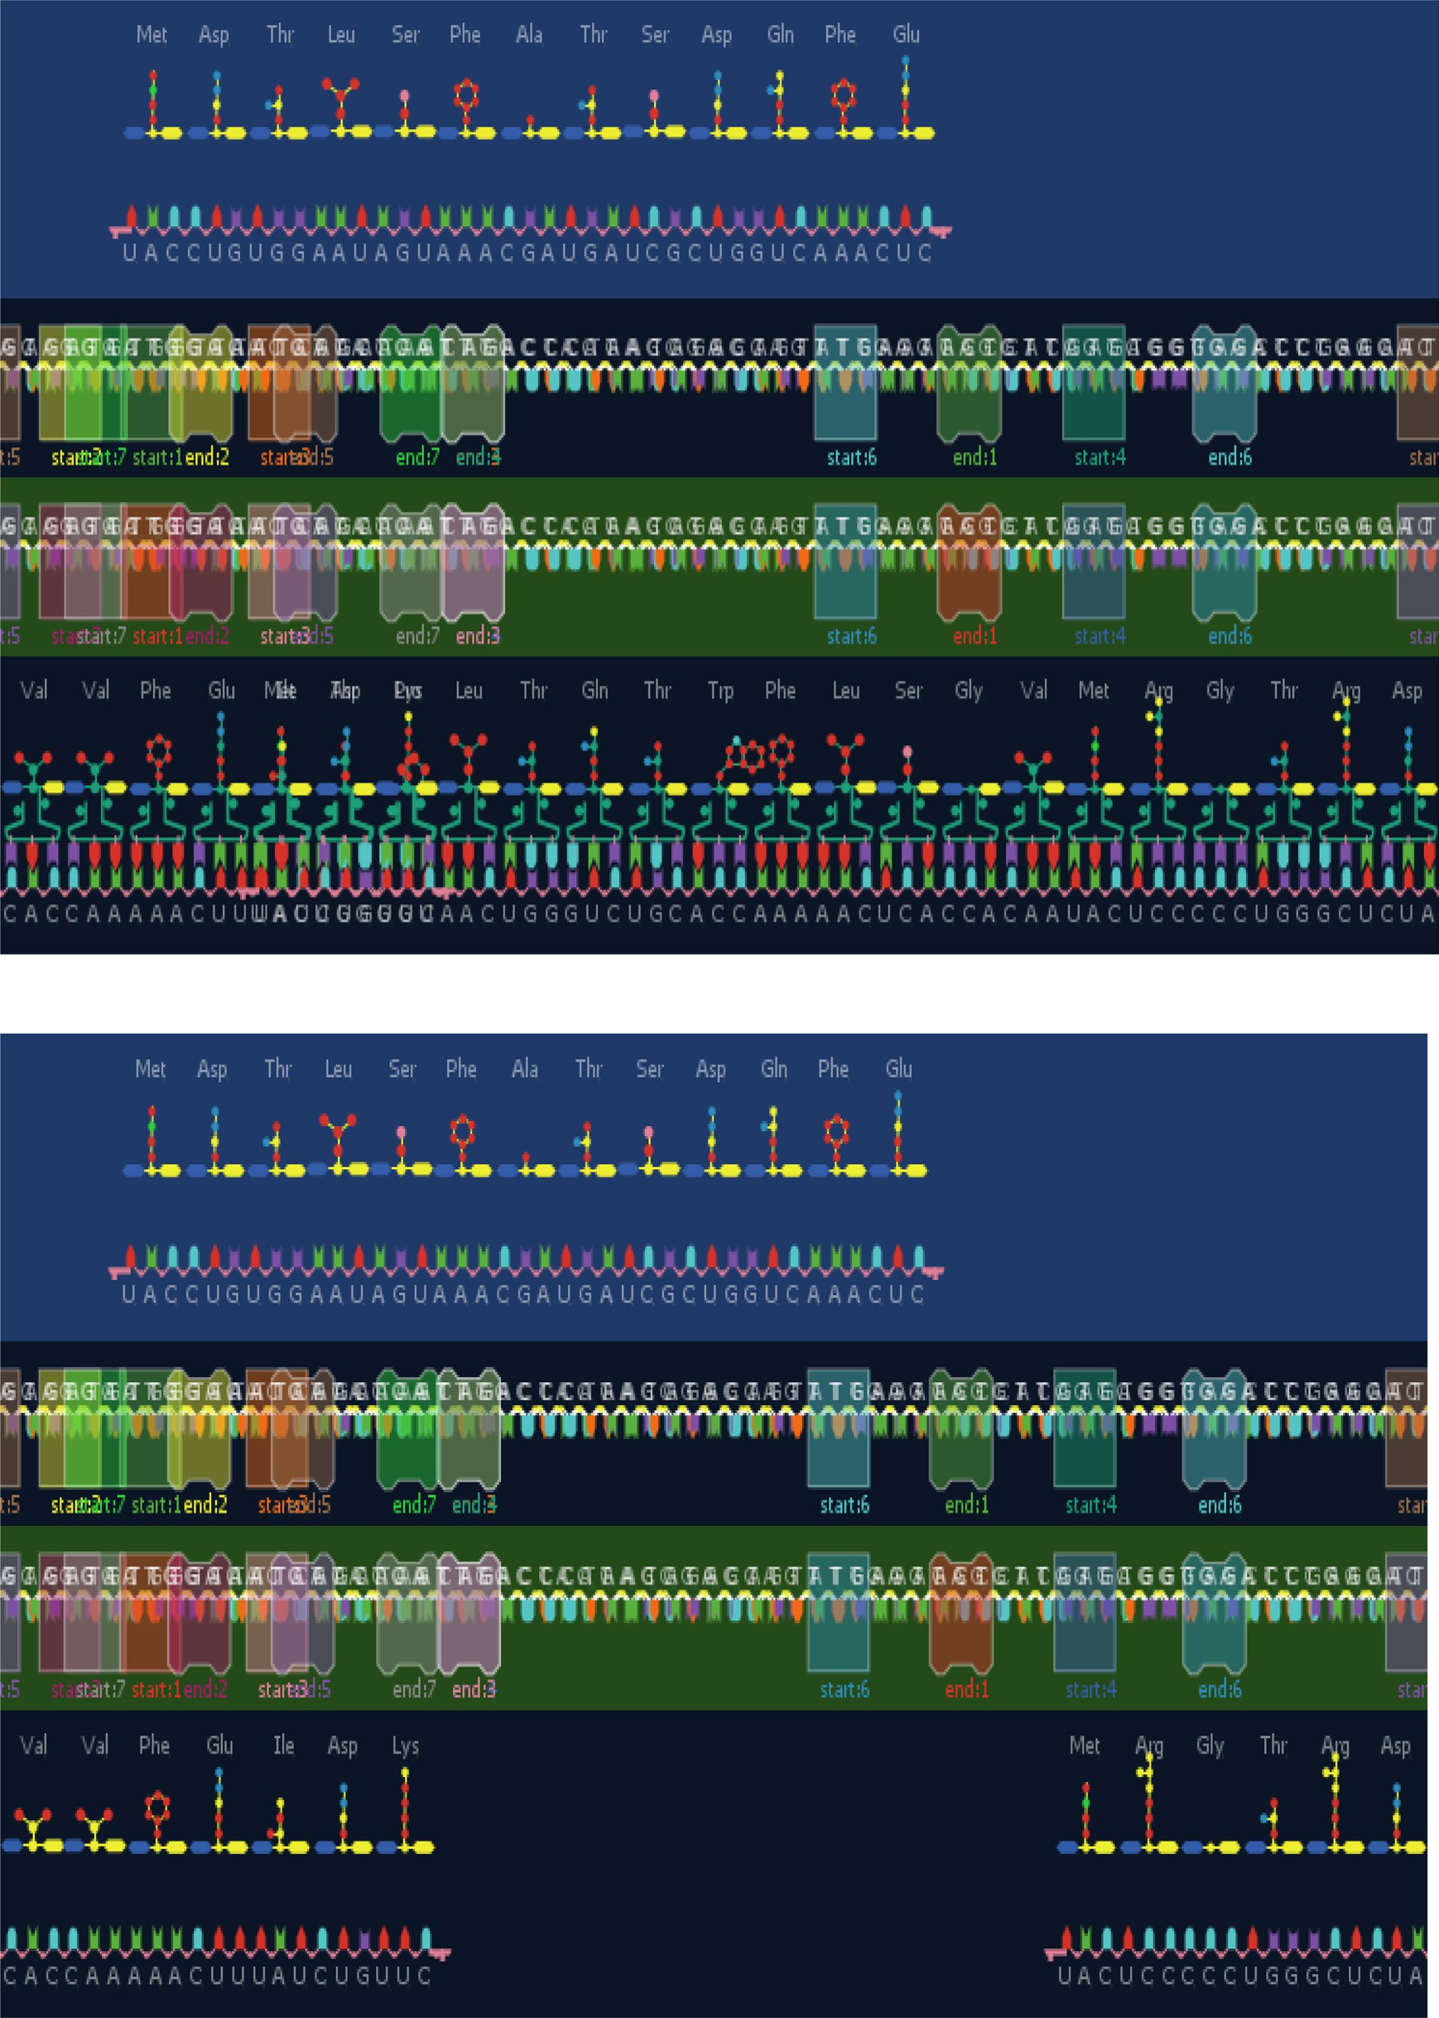

Fig. 12. The Relation between the Number of Iteration and Error.

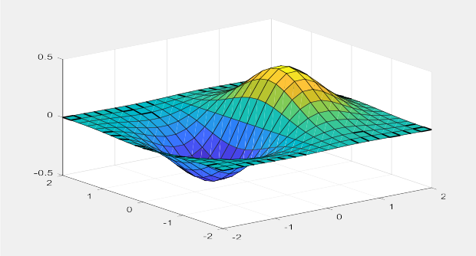

Fig. 13. The Values of Fitness for Lions all Iterations.

teins by Lion-AYAD optimization Algorithm this achieved through applied four types of rules in the final feature add by algorithm called deep composite of triple of tRNA.

The Lion-AYAD algorithm is appear as pragmatic optimization model as explained in Table 8 and Fig. 12 that shown the error rate generation in each iteration, while Fig. 13 presented the values of fitness of lions. Fig. 15 displayed all the results of algorithm from grouping the lions, reduce the cost and increase find the optimal fitness (i.e., solution). Lion-AYAD can apply in other field such as chemistry to reduce the cost, time and human effort by determined the Main Rules (i.e., limitations) to avoiding incorrect interactions of materials, at the same time as optimal model to find optimal new materials can product through interaction among materials computationally before apply the experiment in lab.

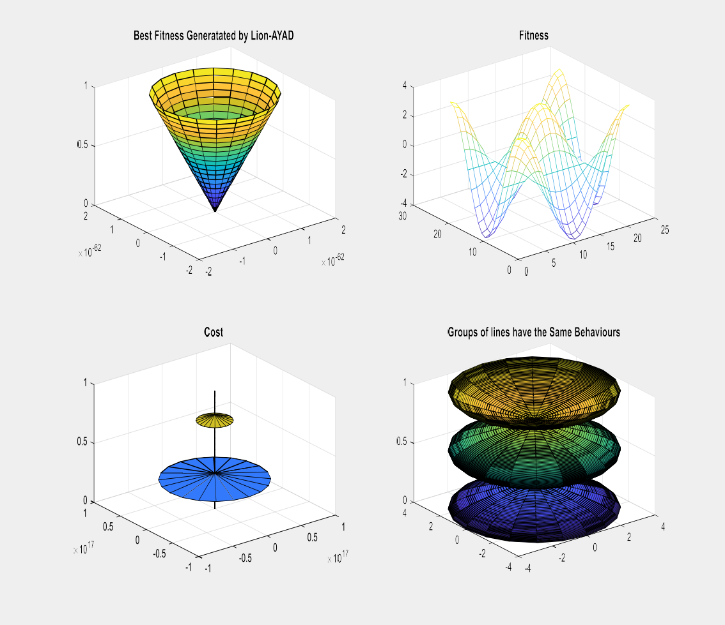

Fig. 14. Results of (a) Best Fitness generated by Lion-AYAD, (b) The Values of Fitness for Best Population, (c) Explain how the Value of cost function reduce to reach of best values, (d) Best number groups of lines population that have the same behaviors results by Lion-AYAD.

|  |  |  |  |  |  |
| --- | --- | --- | --- | --- | --- |
|  | | | | | |
|  |  |  |  |  |  |
|  | | | | | |

Fig. 15. Comparison among Optimization algorithms & Lion-AYAD base on the evaluation measures.

Ethical approval

This article does not contain any studies with human partici- pants or animals performed by any of the author.

Declaration of Competing Interest

The authors declare that they have no known competing finan- cial interests or personal relationships that could have appeared to influence the work reported in this paper.

References

1. [Emary E, Zawbaa HM, Hassanien AE. Binary ant lion approaches for feature](http://refhub.elsevier.com/S1110-8665(22)00004-4/h0005) [selection. Neurocomputing 2016;213:54–65](http://refhub.elsevier.com/S1110-8665(22)00004-4/h0005).
2. [Zawbaa HM, Emary E, Grosan C, Bongard J. Feature selection via chaotic antlion](http://refhub.elsevier.com/S1110-8665(22)00004-4/h0010) [opti-mization. PLoS ONE 2016;11(3):e0150652](http://refhub.elsevier.com/S1110-8665(22)00004-4/h0010).
3. [Gupta S, Kumar V, Rana K, Mishra P, Kumar J. Development of ant lion](http://refhub.elsevier.com/S1110-8665(22)00004-4/h0015) [optimizer toolkit in labview. In: 2016 International Conference on Innovation](http://refhub.elsevier.com/S1110-8665(22)00004-4/h0015) [and Challenges in Cyber Security (ICICCS-INBUSH). p. 251–6](http://refhub.elsevier.com/S1110-8665(22)00004-4/h0015).
4. [Yamany W, Tharwat A, Hassanin MF, Gaber T, Hassanien AE, Kim TH. A new](http://refhub.elsevier.com/S1110-8665(22)00004-4/h0020) [multi-layer perceptrons trainer based on ant lion optimization algorithm. In:](http://refhub.elsevier.com/S1110-8665(22)00004-4/h0020) [2015 Fourth International Conference on Information Science and Industrial](http://refhub.elsevier.com/S1110-8665(22)00004-4/h0020) [Applications (ISI). IEEE; 2015. p. 40–5](http://refhub.elsevier.com/S1110-8665(22)00004-4/h0020).
5. [Rajan A, Jeevan K, Malakar T. Weighted elitism-based ant lion optimizer to](http://refhub.elsevier.com/S1110-8665(22)00004-4/h0025) [solve optimum var planning problem. Appl Soft Comput 2017;55:352–70](http://refhub.elsevier.com/S1110-8665(22)00004-4/h0025).
6. [Kamboj VK, Bhadoria A, Bath SK. Solution of non-convex economic load](http://refhub.elsevier.com/S1110-8665(22)00004-4/h0030) [dispatch problem for small-scale power systems using ant lion optimizer.](http://refhub.elsevier.com/S1110-8665(22)00004-4/h0030) [Neural Comput Appl 2017;28(8):2181–92](http://refhub.elsevier.com/S1110-8665(22)00004-4/h0030).
7. [Ali ES, Abd Elazim SM, Abdelaziz AY. Optimal allocation and sizing of](http://refhub.elsevier.com/S1110-8665(22)00004-4/h0035) [renewable distributed generation using ant lion optimization algorithm.](http://refhub.elsevier.com/S1110-8665(22)00004-4/h0035) [Electr Eng 2018;100(1):99–109](http://refhub.elsevier.com/S1110-8665(22)00004-4/h0035).
8. [Petrovic´ M, Petronijevic´ J, Mitic´ M, Vukovic´ N, Miljkovic´ Z, Babic´ B. The ant lion](http://refhub.elsevier.com/S1110-8665(22)00004-4/h0040) [optimization algorithm for integrated process planning and scheduling. In:](http://refhub.elsevier.com/S1110-8665(22)00004-4/h0040) [Applied Mechanics and Materials. Trans Tech Publ.; 2016. p. 187–92](http://refhub.elsevier.com/S1110-8665(22)00004-4/h0040).
9. [Raju M, Saikia LC, Sinha N. Automatic generation control of a multi-area](http://refhub.elsevier.com/S1110-8665(22)00004-4/h0045) [system using ant lion optimizer algorithm based pid plus second order](http://refhub.elsevier.com/S1110-8665(22)00004-4/h0045) [derivative controller. Int J Electr Power Energy Syst 2016;80:52–63](http://refhub.elsevier.com/S1110-8665(22)00004-4/h0045).
10. [Dubey HM, Pandit M, Panigrahi BK. Ant lion optimization for short-term wind](http://refhub.elsevier.com/S1110-8665(22)00004-4/h0050) [integrated hydrothermal power generation scheduling. Int J Electr Power](http://refhub.elsevier.com/S1110-8665(22)00004-4/h0050) [Energy Syst 2016;83:158–74](http://refhub.elsevier.com/S1110-8665(22)00004-4/h0050).
11. [Mirjalili S, Jangir P, Saremi S. Multi-objective ant lion optimizer: a multi-](http://refhub.elsevier.com/S1110-8665(22)00004-4/h0055) [objective optimization algorithm for solving engineering problems. Appl](http://refhub.elsevier.com/S1110-8665(22)00004-4/h0055) [Intelligence 2017;46(1):79–95](http://refhub.elsevier.com/S1110-8665(22)00004-4/h0055).
12. Al-Janabi S, Alkaim AF. A nifty collaborative analysis to predicting a novel tool (DRFLLS) for missing values estimation. Springer, Soft Comput 2020;24 (1):555–69. doi: <https://doi.org/10.1007/s00500-019-03972-x>.
13. Al_Janabi S, Alhashmi S, Adel Z. Design (More-G) Model Based on Renewable Energy & Knowledge Constraint. In: Farhaoui Y, editor. Big Data and Networks Technologies. BDNT 2019. Lecture Notes in Networks and Systems. Cham: Springer; 2020. doi: [https://doi.org/10.1007/978-3-030-](https://doi.org/10.1007/978-3-030-23672-4_20) [23672-4_20](https://doi.org/10.1007/978-3-030-23672-4_20).
14. Alkaim AF, Al_Janabi S. Multi Objectives Optimization to Gas Flaring Reduction from Oil Production. In: Farhaoui Y, editor. Big Data and Networks Technologies. BDNT 2019. Lecture Notes in Networks and Systems. Cham: Springer; 2020. doi: [https://doi.org/10.1007/978-3-030-](https://doi.org/10.1007/978-3-030-23672-4_10) [23672-4_10](https://doi.org/10.1007/978-3-030-23672-4_10).
15. [Al-Janabi S, Mahdi MA. Evaluation prediction techniques to achievement an](http://refhub.elsevier.com/S1110-8665(22)00004-4/h0075) [optimal biomedical analysis. Int J Grid Utility Comput 2019;10(5):512–27](http://refhub.elsevier.com/S1110-8665(22)00004-4/h0075).
16. Maziar Y, Fariborz J. ‘Lion Optimization Algorithm (LOA): A nature-inspired metaheuristic algorithm. J Comput Des Eng 2016;3(1):24–36. doi: [https://doi.](https://doi.org/10.1016/j.jcde.2015.06.003) [org/10.1016/j.jcde.2015.06.003](https://doi.org/10.1016/j.jcde.2015.06.003).
17. Al-Janabi S, Alkaim A, Al-Janabi E, Aljeboree A, Mustafa M. Intelligent forecaster of concentrations (PM2.5, PM10, NO2, CO, O3, SO2) caused air pollution (IFCsAP). Neural Comput Appl 2021;33(21):14199–229. doi: [https://](https://doi.org/10.1007/s00521-021-06067-7) [doi.org/10.1007/s00521-021-06067-7](https://doi.org/10.1007/s00521-021-06067-7).
18. Al-Janabi S, Alkaim AF, Adel Z. An Innovative synthesis of deep learning techniques (DCapsNet & DCOM) for generation electrical renewable energy from wind energy. Soft Comput 2020;24:10943–62. doi: [https://doi.org/](https://doi.org/10.1007/s00500-020-04905-9) [10.1007/s00500-020-04905-9](https://doi.org/10.1007/s00500-020-04905-9).
19. Al-Janabi S, Kadhum G. Synthesis Biometric Materials Based on Cooperative Among (DSA, WOA and gSpan-FBR) to Water Treatment. In: Abraham A, editor. Proceedings of the 12th International Conference on Soft Computing and Pattern Recognition (SoCPaR 2020). SoCPaR 2020. Advances in Intelligent Systems and Computing. Cham: Springer; 2021. doi: [https://doi.org/10.1007/](https://doi.org/10.1007/978-3-030-73689-7_3) [978-3-030-73689-7_3](https://doi.org/10.1007/978-3-030-73689-7_3).
20. Al-Barmani Z, Al-Janabi S. Intelligent Data Mining Techniques to Verification of Water Quality Index. In: Abraham A, Hanne T, Castillo O, Gandhi N, Nogueira Rios T, Hong TP, editors. Hybrid Intelligent Systems. HIS 2020. Advances in Intelligent Systems and Computing. Cham: Springer; 2021. doi: [https://doi.](https://doi.org/10.1007/978-3-030-73050-5_58) [org/10.1007/978-3-030-73050-5_58](https://doi.org/10.1007/978-3-030-73050-5_58).
21. Al-Janabi S, Salman AH. Optimization Model of Smartphone and Smart Watch Based on Multi Level of Elitism (OMSPW-MLE). In: Misra S, Kumar TA, Piuri V, Garg L, editors. Artificial Intelligence for Cloud and Edge Computing. Internet of Things (Technology, Communications and Computing). Cham: Springer; 2022. doi: <https://doi.org/10.1007/978-3-030-80821-1_7>.
22. Mahdi MA, Al_Janabi S. A Novel Software to Improve Healthcare Base on Predictive Analytics and Mobile Services for Cloud Data Centers. In: Farhaoui Y, editor. Big Data and Networks Technologies. BDNT 2019. Lecture Notes in Networks and Systems. Cham: Springer; 2020. doi: [https://doi.org/10.1007/](https://doi.org/10.1007/978-3-030-23672-4_23) [978-3-030-23672-4_23](https://doi.org/10.1007/978-3-030-23672-4_23).